Promoting Sustainable Livelihoods in TFCAs – ProSuLi, 10-months update.

Supporting the long-term sustainable management of TransFrontier Conservation Areas in southern Africa (Botswana, Mozambique, Zimbabwe) through a multi-stakeholder participatory process to co-design sustainable management options.

Funded by the European Union, Grant FED/2017/394-443

Dates: 2018-2021

Objectives of the project
The ProSuLi project aims at promoting and strengthening the sustainability of TFCAs by exploring local development initiatives meaningful for local stakeholders and long-term biodiversity conservation, promoting a paradigm shift in thinking the contribution of local communities in the co-management of TFCAs. The main objective of ProSuLi is to create, or capacitate when already existing, functional multi-stakeholder interaction processes at a local scale to reconcile the management of local resources and local well-being. The project will adopt the process of Commoning to promote dialogue between multiple and potentially conflicting views, by diagnosing existing conflicts and collectively investigating management options and co-designing innovative institutional organizations. It aims at redefining collectively the allocation of users’ rights over shared resources, the rules of inclusion and exclusion of the right-holders, as well as the terms and conditions of costs and benefits sharing.

We postulate that such process of collectively investigating, promoting and monitoring a common goal among stakeholders, beyond each individual groups’ constraints or interests, can set the path for developing or strengthening the involvement of all stakeholders into TFCA governance and conciliate conflicting views about wildlife management options.
We will follow three main principles:
- the SUSTAINABILITY of the action so that when the project stops, the multi-stakeholder collaboration process can carry on and serves its role as a local governance tool for managing problems and opportunities in the socio-ecosystem;
- the REPRESENTATIVITY of people involved in the participatory process so that objectives of social equity are met and activities implemented fulfil their role to benefit many, especially the one in need of support;
- the action is NOT ABOUT RE-INVENTING THE WHEEL because each socio-ecosystem has its own history and experiences, understanding that ProSuLi is not a stand-alone project but a project continuing what is been done previously and preparing the floor for the next projects/initiatives.
Update on implementation
The activities started in the four sites of the ProSuLi project. The first year of the project is dedicated to the context analysis including past projects and history of the areas, stakeholders’ engagement and trust building, the implementation of Co-elaborative scenario-building (Futures thinking – see box) and the identification by local stakeholders of the activities they want to co-design, implement and monitor within the framework of and facilitation by the project.

Co-elaborative scenario-building: What for? And How?`
This approach is adapted from the French school of “La prospective” (Godet, 1986, 2010). It consists in the production of scenarios at local level for - and by - local stakeholders. Developing scenario aims at helping the doers (aka stakeholders) to think about the future. The purpose of this approach is to provide local actors with i) the skills to generate their own scenarios and explore their futures - a capability development dimension, and ii) the possibility to become pro-active, - an empowerment dimension. In this approach, plausibility prevails over probability for two reasons: i) it is used to explore situation characterized by a high degree of uncertainty, and ii) the potential for local agency that would result from its implementation would directly affect the expected likelihood of the scenarios. The technical sequence of the co-elaborative scenario building approach entails the elements presented below.

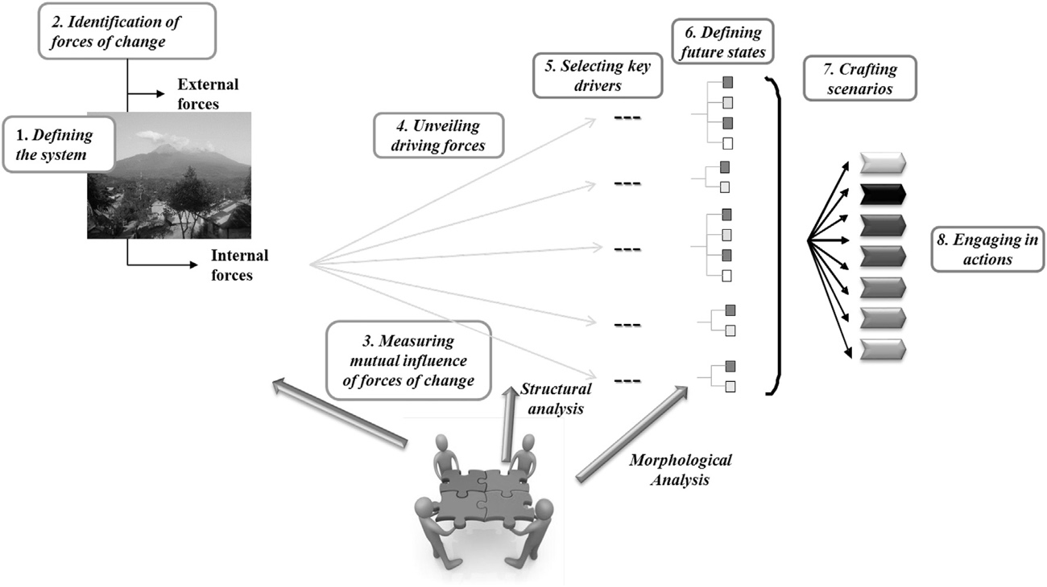

This technical sequence develops through a co-construction process where participants are seen as “experts” who provide elements of the knowledge needed and contribute to the gradual elaboration of the scenarios. Contradictory views or disagreements are discussed and regulated through an agreed-upon rule of acquiescence (Laffont, 2012). The whole process requires also trained facilitators, a careful selection of the participants relying on specific principles and personality traits, and their continuous presence throughout the whole process.

Adapted from : R. Bourgeois et al. Technological Forecasting & Social Change 124 (2017) 178–188

Quick update and trends by site

Maese site (Greater Seronga area, Eastern Panhandle, Botswana)
After a stakeholder engagement process and a context analysis work, a Futures workshop was held in August 2018 and a restitution mission was organised subsequently. Locally there is an existing strong engagement of local NGOs (e.g; CLAWS – Carnivore conservation NGOs) with an excellent knowledge of the area and already on-going innovative activities related to mitigating Human/Wildlife conflict. The ProSuLi project will engage with them and other NGOs (e.g. Conservation International & PPF) and the local private wildlife industry of the Okavango Delta in sustainable cattle and rangeland management in order to produce conservation-friendly beef that could meet a local private tourism industry demand. Currently, a legal scientist investigates the legal aspects of meat production in the local context.

Nelukoba site (Ward 15, Hwange district, Zimbabwe)
In the Nelukoba site, the context analysis revealed the complexity and diversity of local stakeholders and associations (working mainly on conservation or H/W conflicts issues) necessitates more dwelling into the current and dynamic power relationships between stakeholders. Many research projects conducted with the Hwange LTSER have contributed to better understand the social and ecological dynamics and need to be accounted for in the ProSuLi process to ensure the best value for the project. A MSc student has been recruited to work on these aspects. The district and local authorities have accepted the objectives of the project. The Futures workshop is scheduled in March 2019 and should provide which activities will be supported by the project through the participatory process.

Mangalane site (Mangalane community, Moamba district, Mozambique)
This site is very sensitive given the issues of rhinoceros poaching and its impact on local development. Numerous missions have been organised in order to establish trust between local communities and members of the Eduardo Mondlane University. The Futures workshop is scheduled in March 2019. However, given the current knowledge on the local situation, it seems that issues around access and collective management of water for both livestock and human consumption are crystallising conflicts between stakeholders. In addition, human/wildlife conflicts (elephant raiding and carnivore predation) focus also a lot of misunderstanding about responsibilities and mistrust between stakeholders. Finally, the fair access of the 20% revenue from the wildlife sector activities by local communities can also provide a collective action opportunities for stakeholders. The Theatre Forum methodology should be used in this site.

Sengwe site (Ward 15, Chiredzi district, Zimbabwe)
In Sengwe, trust exists between the project members and local stakeholders following on-going activities by the RP-PCP for more than 10 years. A Futures workshop has been organized in November 2018 and a restitution is due as soon as the political context in Zimbabwe allows it. Activities should be identified during this mission. Expected activities following the first interaction with local stakeholders: adaptation to climate change through livestock feed conservation; collective management of cattle; rangeland management.

More information
Alexandre Caron, Cirad, RP-PCP Coordinator, Maputo, Mozambique, alexandre.caron@cirad.fr
Nicolas Gaidet, Cirad, Montpellier, France, nicolas.gaidet-drapier@cirad.fr
Link to project leaflet
Website: www.rp-pcp.org & https://www.rp-pcp.org/projects/on-going/eu-prosuli
You can find us on twitter: @rp_pcp

Picture: Happy participants after 3 days of Futures Workshop in Malipati village, Ward 15, Chiredzi district, Zimbabwe, GLTFCA: the ProSuLi team could not decide if they were happy of the work and results produced or because this labour-intensive workshop was ending, or both.

