SADC/GIZ Project
“Transboundary Use and Protection of Natural Resources in the SADC Region”
Application Form for Project Proposals on
Cross Border Climate Change Adaptation
Proposals may be on different types of activities like water management, adaptive agriculture, wildlife management etc. They have to be planned and managed jointly by NGOs or government institutions of at least 2 countries of a TFCA and with the active participation of local communities. Proposals that have a positive impact on these communities by securing the livelihood and/or improving their income will have preference in the selection process. Proposals concerning only one country will not be considered for support by the SADC/GIZ project.
Please give contact details of the institution and the person responsible for the application and the implementation of the project (name, position, telephone and e-mail address):
Ezemvelo KZNWildlife
Ms Joyce Loza, Conservation Specialist, P.O. Box 1362 Howick, 3290, South Africa
Tel.: +27 33 2391885, Cell: +27 72 016 1196, Fax: +27 33 2391895, Email: joyce.loza@kznwildlife.com

Please give the contact details of the institution and the person responsible for the management of the GIZ funds in case the proposal should be selected.
Mr. Rabson Dhlodhlo, Project Coordinator, P.O. Box 1362, Howick, 3290, South Africa
Tel.: +27 33 2391884, Cell: +27 83 282 0900, Fax: +27 33 2391895, Email: rabson.dhlodhlo@kznwildlife.com

- General information
- Name of the TFCA and participating countries:
MALOTI DRAKENSBERG TRANSFRONTIER CONSERVATION AND DEVELOPMENT PROGRAMME. Participating countries are Lesotho and South Africa.
- Project title:
Implementing wetland rehabilitation to respond to drought in the Maloti Drakensberg Transfrontier Focus Area
- TFCA belongs to category A,B or C as defined in the SADC TFCA Programme:
A (with treaty), B (without formal agreement yet) or C (exist as concept): A
- Funds requested: Euro 49 455.42
- Background information(max.½ page, font 12):
The Maloti Drakensberg Mountains are a water hub. The alpine mountain region is the “water factory” of the subcontinent. The Mountains provided 20-30% of the water needed by the subcontinent. It also provides about 50% of the water to industrial city of Gauteng via the uTugela-Vaal Transfer Scheme. Rivers and wetlands in the Maloti Drakensberg Transfrontier Conservation Area (MDTFCA) contribute to water quality and quantity in the region, and the MDTFCA has a unique wetland complex.
Wetlands are one of the threatened ecosystems in the critically important ecosystems of the MDTFCA; as such, focus is on addressing their improved management. Apart from being a major sink for carbon, wetlands are also a key feature for retaining water. Some of the inherent and unique characteristics of wetlands benefiting both humans and nature are the protection of the areas’ ecology and improvement of water quality, the provision of fish and wildlife habitats, storing flood waters, and maintaining surface water flow during dry periods. Threats to these wetlands are contributing the issue of climate change by impairing their functionality as carbon sinks. There is a need to rehabilitate these wetlands to maintain and enhance their carbon sink function in response to climate change. Their proper management will address climate change adaptation by regulating water provisioning and storage and thus helping ameliorate drought which is often experienced in the MDTFCA.
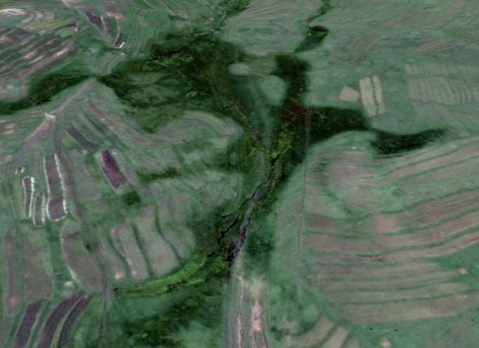
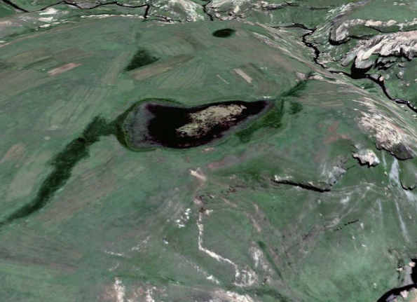
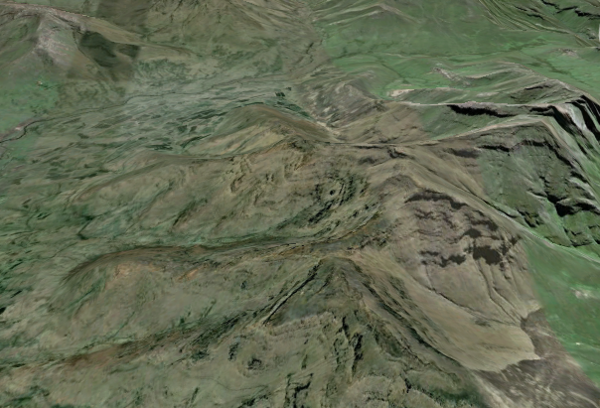
Project Location

Figure1: Sehlabathebe National Park proposed rehabilitation sites
The western part of Sehlabathebe National Park is bordered by a cluster of 14 villages which are part of the greater Khomo-Phatšoa Community Council - an area of 46 630 ha managed as a managed resource area (MRA) with a community council endorsed natural and cultural heritage management plan. Thamathu is among these 14 villages.
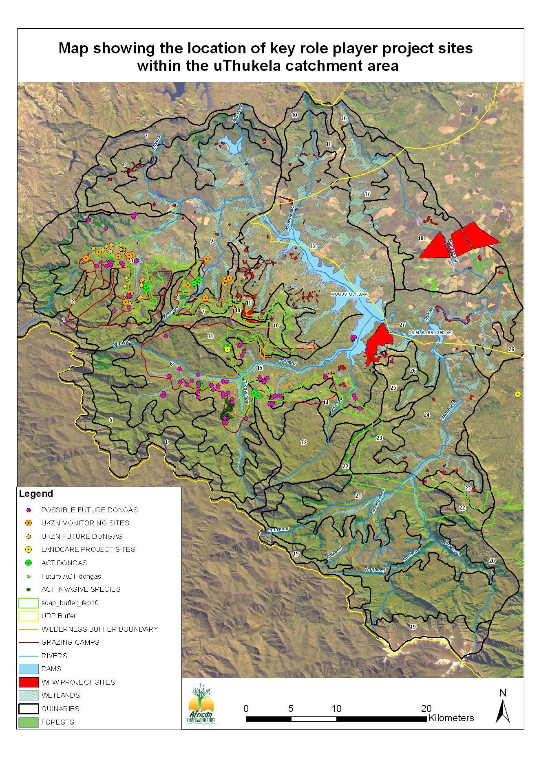
Figure1: Depicts the boundary within which the project will be implemented in KwaZulu Natal Province, South Africa
On the South African side the project will be implemented in the rural areas of the uThukela District and within the upper uThukela Catchment in the in Ngoba and MaSwazini in western KwaZulu Natal (see below figure) and is made up of 9 quaternary catchments. This area is one of a few areas in South Africa country which serve as a major source of water and the wetland features of the uKhahlamba Drakensberg Park World Heritage Site are mirrored in the Upper uThukela Catchment.

- Project narrative (max. 1 page, font 12):
The main climate change issue now experienced in the MDTFCA is DROUGHT. The main impact of drought is the drying of the rivers, siltation in rivers, and reduced water supply. Reduced water is mainly caused by lower rainfall especially during dry seasons. Wetlands, which are a major source of water to strategic rivers in the MDTFCA are degraded, which compounds the problem of drought and thus they need to be rehabilitated.
The objective of the project is to:
- Implement rehabilitation of wetlands in order to enhance their function as carbon sinks and regulators and providers of water to the ecosystem.
- Implement rangeland management in rangelands surrounding wetlands in order to restore and improve ecosystem health and prevent further wetland and rangeland degradation
Goal 1: Implement rehabilitation of wetlands in order to enhance their function as carbon sinks and regulators and providers of water to the ecosystem.
  - To identify wetlands that needs rehabilitation within the catchment
  - To establish climate change steering committee
  - To set goals and objectives of the project.
  - To construct stone lines on the slope to reduce the rate of surface run off and soil erosion. The surveying and levelling equipment will used to ensure that construction is parallel to the natural contour lines.
  - To construct closed pasture furrows on the slope to reduce the rate of surface run off and soil erosion. The surveying and levelling equipment will used to ensure that construction is parallel to the natural contour lines.

Goal 2: Implement rangeland management in rangelands surrounding wetlands in order to restore and improve ecosystem health and prevent further wetland and rangeland degradation
- To setup community based project implementation, monitoring and support structures that will carry-on the project objectives beyond funding period.
- To develop, implement a grazing management plan through participatory planning with local farming communities.
- To provide basic resources to enhance grazing management in project areas.
- To develop and implement proper monitoring frameworks for the grazing management plan.

The proper functionality of wetlands will enhance carbon sequestration, and reduce its effects to climate change, as well as regulate water and enhance the provision of water to the MDTFCA. Thus this mitigation measure will enhance adaptation of the ecosystem and associated wetlands to the impacts of Climate Change.
Other benefits include the improvement of livelihoods for local communities through short term employment of local household’s members to conduct the rehabilitation, as well as the obvious benefit of regulated water for domestic use and agriculture.
Outputs: 86 hectares wetland area re-vegetated, 16 jobs created on the Lesotho side, 22 Gabion structures, 22 Concrete, 22 Earthworks, 22 Earth structures constructed.
Outcomes - Result to be achieved: Enhancing the function of the wetland for filtration to improve water quality (this will ensure that the water that is supplied to the rivers is of good quality) – reduce the risk of waterborne diseases, enhanced water retention and infiltration functionality, and enhance the functionality of wetlands as carbon sinks.
Improved ecosystem health - rangelands, improved quality of livestock, social cohesion, and improved livestock security through livestock herding in the long term.
Project Activities
- Planning meeting with stakeholders– this will include a) conducting of pre-rehabilitation site visits and agreeing on processes, identification of training requirements b) Establishment of a Project Steering Committee (PSC) facilitated by MDTP and MTEC but led by the community representatives. c) Identification and appointment of beneficiaries through the Project Steering Committee (PSC).
- Procurement of material, equipment and Personal Protective Clothing (PPP).
- Implement training.
- Rehabilitation process.
- Monitoring and evaluation.
- Monthly progress meetings.
Participating organization is: Ezemvelo KZNWildlife: Ezemvelo KZNWildlife is the implementing institution.
MDTP: Responsible for coordinating implementation of the project and reporting to funders.
- Time schedule for the planned activities(in tabular form,1 page):
TASKS | 2014 YEAR 2015  MONTHS
 | Aug | Sept | Oct | Nov | Dec | Jan | Feb | March | April
Planning meeting with stakeholders
Establishment of a Project Steering Committee (PSC)
Identification and appointment of beneficiaries
Procurement of material, equipment and Personal Protective Clothing (PPP)
Training of participants on rehabilitation.
Rehabilitation process
Post-rehabilitation assessments
Monthly reporting
Close out report

- Budget (1 page),
OUTPUT | COST in Rand | COST in EURO | % of Project Budget
Workshops, catering, venue hire | R 40 000.00 | EUR 2 657.81 | 5.37
Wage to participants | R 338 400.00 | EUR 22 485.05 | 45.47
Transport | R 40 000.00 | EUR 2 657.81 | 5.37
Material and Equipment | R 205 000.00 | EUR 13 621.26 | 27.54
Protective Clothing | R 37 600.00 | EUR 2 498.34 | 5.05
Consumables | R 8 000.00 | EUR 531.56 | 1.07
Training | R 55 000.00 | EUR 3 654.49 | 7.39
Compensation Fund | R 16 920.00 | EUR 1 124.25 | 2.27
UIF | R 3 384.00 | EUR 224.85 | 0.45
PROJECT BUDGET TOTAL | R 744 304.00 | EUR 49 455.42 | 100

Workshops, catering, venue hire: These include logistics for workshops such as catering and venues hired. Wage to
participants: These are funds set aside for paying wage incentives to participants (local community members) in rehabilitation. Transport: This is transport hired to take participants from assemble point to the work area in areas where they cannot access the work area on foot. Material and Equipment includes: Gabion structures, concrete structures, earthworks, earth structures, material for re-vegetation, a movable toilet. Personal Protective Clothing (PPE): Gumboots, gloves, overalls, Tshirts, rain suits, dusts masks. Consumables: First aid kit, soaps, detergents, toilet paper, fire extinguisher. Compensation fund: Set aside for injuries on duty for all participants according to the Compensation for Injury on Duty law administered by the Department of Labour. UIF: Is 1% of the salary bill set aside for participants to claim from the Department of Labour in case they lose their jobs.
Ezemvelo KZNWildlife will contribute human resources, communication resources (telephones, emails, fax), venues for meetings where necessary, transport and subsistence and allowance to own staff involved in coordinating the project.

- ANNEXURE A: DETAILED WORK PLAN AUGUST 2014 TO APRIL 2015
Table 3: Detailed Work plan August 2014 to April 2015
IMPLEMENTING WETLAND REHABILITATION TO RESPOND TO DROUGHT IN THE MALOTI DRAKENSBERG TRANSFRONTIER FOCUS AREA
WORKPLAN AUGUST 2014 TO APRIL 2015
Milestones (special attention is to be given to the below milestones) | Products / Deliverables | Activities | Timelines | Budgets
Component 1.  Project initiation and identification of priority wetlands areas to be targeted. | 1.1.  Report on the outcome of the meeting, photos of areas to be targeted for rehabilitation, status report for areas to be rehabilitated produced within the 1st month of the project initiation stage, details of beneficiaries employed.  Project Steering Committee (PSC) established.  Project Implementation Committee (PIC) established.  Attendance register and minutes of meeting.  Beneficiaries identified and appointed. 16 Jobs created in Lesotho  Material, Consumables and Personal Protective Clothing procured. | Activity 1.1.1  Meeting with stakeholders to formally introduce the project and agree on activities and timelines.  Activity 1.1.2  Phase1: Appoint an Environmental Assessment Practitioner to conduct a specialist assessment of wetlands. Agree on identified areas.  Phase 2: Conduct an Environmental Impact Assessment, submit for Environmental Authorisation and produce a rehabilitation report.  Activity 1.1.3  Meeting to appoint the PSC and PIC.  Activity 1.1.4  Interviews to appoint beneficiaries through the PSC.  Activity 1.1.5  Procurement of Material, Consumables and Personal Protective Clothing. | 01st Aug 14 – 30th Sept 14 | EUR 10 000.00  EUR 66.66  EUR 16 651.16

Components | Products / Deliverables | Activities | Timelines | Budgets
Component 2.  Capacity on wetland rehabilitation built amongst the project beneficiaries. This includes trans-boundary learning exchanges. | 2.1.  Report on training matrix and training conducted depicting the type of training provided, period of training and the number of beneficiaries trained. 16 beneficiaries trained.  2.2.  Report on learning exchanges on wetland rehabilitation conducted between Lesotho and South African beneficiaries. Beneficiaries benefited from the learning exchange | Activity 2.1.1  Develop a training matrix based on the wetland rehabilitation requirements. Implement training agreed upon. This will differ from wetland to wetland. Some wetlands are invaded by invasive alien plants and may need to be cleared to enhance their functioning. Some invasive alien plants are within the catchments that are invaded by invasive alien plants, where clearing on these foreign species will enhance the functioning of the entire catchment. The type of training will depend on the outcomes of Activity 1.1.2 above. This activity includes procurement of professional training service providers, training venue hire and catering for beneficiaries during training.  Activity 2.2.1  Conduct learning exchanges (one per country) on wetland rehabilitation amongst beneficiaries in each country to encourage learning from each other experience. This entails transporting (beneficiaries may also need accommodation given the distances between the two countries) project beneficiaries from Lesotho to South Africa and vice versa to engage in an onsite learning experience from one another. This is also aimed at establishing and strengthening relationships between Lesotho beneficiaries and their SA counterparts. This will also be an opportunity for the PSC members to engage in capacity building. | 01st Aug 14 – 30th Sept 14  01st Jan 15 – 30th April 15 | EUR 3 654.49
Components | Products / Deliverables | Activities | Timelines | Budgets
Component 3.  Wetland areas and their associated catchments rehabilitated. Monitoring and evaluation conducted. | 3.1.  86 hectares area cleared of invasive alien plants.  86 hectares area re-vegetated where necessary.  22 Gabion structures, 22 Concrete, 22 Earthworks, 22 Earth structures constructed.  Report on the number of days worked and wages paid per month. 22 days of work per person per month over 7 months and 22days of training total over 9 months.  3.2.  Report on post rehabilitation site visits and monthly progress meetings. | Activity 3.1.1  Clearing of invasive alien plants. Identification of indigenous grass plugs wetland species to be used to re-vegetate. The indigenous grasses will be propagated. Purchasing of seedlings of Hyparrhenia, Paspalum and Melinus (confirmation on the species is required) and transplanted in areas with severe sheet erosion. Construction of 22 Gabion structures, 22 Concrete, 22 Earthworks, 22 Earth structures. Construction of gully head structures through the use of gabions and stones. Gully reshaping with the use of spades and pick axe to prevent widening of the gully. Construct silt traps / check dams to prevent deepening of the gully. Construction of the stone lines. Grass reseeding on the reshaped gully and on the patches. Construction of furrows above the fields which adjacent to the wetlands to reduce sedimentation. River monitoring on key indicator species Construction of the pasture furrows with the use of spades and pick axes. Due to the short project life span, activities that will trigger environmental authorisation will be avoided, because of the length of time it will take to get authorisation. Where distances to rehabilitation sites are not accessible on foot, beneficiaries will be transported to the sites. Beneficiaries will be paid an average of R120 per person per day over 8 months. The wage paid includes wage paid during working and training days. Training will be done in one month (over 22 days)  Activity 3.2.1  Conduct post-rehabilitation site visits and compile a report on the outcomes. This will be done at the end of each moth and before any payment is done to the beneficiaries. This is part of monitoring and evaluation for implementation of the project activities and signing off on work done and entails going to site with beneficiaries to verify work done. | 01st Jan 15 – 30th April 15 | EUR 22 485.05
Components | Products / Deliverables | Activities | Timelines | Budgets
Component 4.  Implementation of a rangeland management plans compliments efforts of rehabilitation and prevent further degradation | 4.1.  Stakeholder consultation and awareness, address institutional arrangements.  4.2.  Baseline data collected and grazing management plan developed. | Activity 4.1.1  Meeting with Principal Chief to introduce the concept of grazing management. Logistics will be – Transport, accommodation and catering.  Identify stakeholders that should be involved including departments and local community structures – List of stakeholders.  Invite all stakeholders to a meeting to introduce the project and discuss roles and responsibilities.  Activity 4.1.2  Conduct veld condition assessments to get the baseline of vegetation in the rangelands spanning the wetlands that will be rehabilitated – On the Lesotho side Department of Soil, Livestock and Water Conservation can do this for the project.  Develop the grazing management plan – conduct site visits with farmers to develop the plan (the farmers already know the area, they know which areas are to be grazed when, therefore are crucial to the process).  Ensure that the grazing management plan if fully integrated within the permits issued to farmers and the Grazing Associations constitution so that they can monitor it.  Ensure that the grazing management plan is fully integrated within the Department of Range Resources Grazing Control Officers so that they also are responsible for monitoring it.  Ensure that livestock health as required by the grazing permits is well monitored.  Purchase of mobile kraals where possible that will be used to densify livestock, livestock herding using kraals. | 01st Jan 15 – 30th April 15  01st Jan 15 – 30th April 15
Component 5.  Project administration maintained. | 5.1.  Report on meetings held per month and linked expenditure on venue hire and catering, transport and accommodation for learning exchanges. At least 7 meetings are planned over 9 months of the duration of the project. | Activity 5.1.1  Organise meetings, meeting logistics such as venue hire and catering. Organise learning exchanges and logistics such as transport and accommodation. | 01st Jan 15 – 30th April 15 | EUR 2 524.49
Table 4: Detailed Project Budget
ITEM | Aug | Sept | Oct | Nov | Dec | Jan | Feb | March | April | COST in Rand | % of Project Budget
CATERING | R 0.00 | R 1 000.00 | R 1 000.00 | R 2 000.00 | R 2 000.00 | R 1 000.00 | R 1 000.00 | R 1 000.00 | R 1 000.00 | R 10 000.00 | 1.34
TRANSPORT | R 0.00 | R 0.00 | R 2 000.00 | R 2 000.00 | R 2 000.00 | R 2 000.00 | R 2 000.00 | R 2 000.00 | R 2 000.00 | R 14 000.00 | 1.88
REHABILITATION MATERIAL AND EQUIPMENT | R 0.00 | R 0.00 | R 90 300.00 | R 55 790.06 | R 0.00 | R 0.00 | R 0.00 | R 0.00 | R 0.00 | R 146 090.06 | 19.63
PROTECTIVE CLOTHING | R 0.00 | R 35 000.00 | R 35 000.00 | R 0.00 | R 0.00 | R 0.00 | R 0.00 | R 0.00 | R 0.00 | R 70 000.00 | 9.40
CONSUMABLES | R 0.00 | R 0.00 | R 1 428.57 | R 1 428.57 | R 1 428.57 | R 1 428.57 | R 1 428.57 | R 1 428.57 | R 0.00 | R 8 571.42 | 1.15
Wage to beneficiaries | R 0.00 | R 18 800.54 | R 37 600.00 | R 37 600.00 | R 37 600.00 | R 37 600.00 | R 37 600.00 | R 37 600.00 | R 37 600.00 | R 282 000.54 | 37.89
ACCOMMODATION | R 0.00 | R 0.00 | R 0.00 | R 3 000.00 | R 3 000.00 | R 0.00 | R 0.00 | R 0.00 | R 0.00 | R 6 000.00 | 0.81
VENUE HIRE | R 0.00 | R 0.00 | R 625.00 | R 625.00 | R 625.00 | R 625.00 | R 625.00 | R 625.00 | R 0.00 | R 3 750.00 | 0.50
CONSULTANT FEES | R 0.00 | R 100 000.00 | R 50 000.00 | R 0.00 | R 0.00 | R 0.00 | R 0.00 | R 0.00 | R 0.00 | R 150 000.00 | 20.15
TRAINING CONSULTANT | R 0.00 | R 0.00 | R 23 100.00 | R 0.00 | R 0.00 | R 0.00 | R 0.00 | R 0.00 | R 0.00 | R 23 100.00 | 3.10
TRAINING MATERIAL | R 0.00 | R 0.00 | R 15 000.00 | R 0.00 | R 0.00 | R 0.00 | R 0.00 | R 0.00 | R 0.00 | R 15 000.00 | 2.02
Compensation Fund (This is required by law to ensure that beneficiaries are able to claim in the case of Injury on Duty) | R 0.00 | R 0.00 | R 1 880.00 | R 1 880.00 | R 1 880.00 | R 1 880.00 | R 1 880.00 | R 1 880.00 | R 1 880.00 | R 13 160.00 | 1.77
Unemployment Fund (required by law to ensure that beneficiaries are able to claim from this fund when employment ceases, or when they are on maternity leave and are not receiving an income). This is 1% of the wage bill. | R 0.00 | R 0.00 | R 376.00 | R 376.00 | R 376.00 | R 376.00 | R 376.00 | R 376.00 | R 376.00 | R 2 632.00 | 0.35
 | R 0.00 | R 154 800.54 | R 258 309.57 | R 104 699.63 | R 48 909.57 | R 44 909.57 | R 44 909.57 | R 44 909.57 | R 42 856.00 | R 744 304.02 | 100.00

- Budget narrative
- Wage to beneficiaries: covers paid to beneficiaries during training and also working days.
- Catering will be done during monthly meetings, training sessions and during the learning exchange site visits
- for project beneficiaries and members of the PSC.
- Transport covers transportation of beneficiaries from their pick up point to the sites where training and rehabilitation will be taking place. It also covers transportation of beneficiaries and their PSC during the learning exchange visits.
- Material and Equipment includes: Gabion structures, concrete structures, earthworks, earth structures, material for re-vegetation, a movable toilet.
- Personal Protective Clothing (PPE): Gumboots, gloves, overalls, Tshirts, rain suits, dusts masks. Consumables: First aid kit, soaps, detergents, toilet paper, fire extinguisher.
- Compensation fund: Set aside for injuries on duty for all participants according to the Compensation for Injury on Duty law administered by the Department of Labour.
- Unemployment Fund (UIF): Is 1% of the salary bill set aside for participants to claim from the Department of Labour in case they lose their jobs.

Table 5: Employment Figures
Month | April | May | June | July | Aug | Sept | Oct | Nov | Dec | Total
No of beneficiaries | 16 | 16 | 16 | 16 | 16 | 16 | 16 | 16 | 16 | 16
Number of days work | 0 | 10 | 22 | 22 | 22 | 22 | 22 | 22 | 22 | 164
Number of days training | 10 | 12 | 0 | 1 | 1 | 0 | 0 | 0 | 0 | 24

16 Beneficiaries will be employed and paid a wage rate average of R 120.00 per day. Employment will be for 22 days a month over the duration of the active months of the project. There will be no work over holidays, weekends and during rainy days. On red days, work will start early and finish early escaping the sun. The 24 days for training include 2 days for the learning exchange by each group of beneficiaries.
- Short-Long Term Impacts (1 year)
- Regrowth of natural wetlands plant species – increase in plant diversity.
- Increase in carbon sink characteristics of the wetlands.
- Return of bird species inhabiting wetlands such as the cranes.

