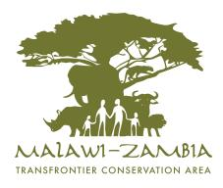
INTEGRATED DEVELOPMENT PLAN
2014 - 2023

Malawi-Zambia Transfrontier Conservation Area Integrated Development Plan Working Group of the Bilateral Technical Committee



Copies of this Report can be obtained from:
MALAWI  Principal Secretary – Ministry of Information, Tourism and Culture  Address: Tourism House, Private Bag 328 <Add> LILONGWE │ Malawi  Tel: +265, 1 775 499<Add>  E-mail: ps@visitmalawi.mw <Add>  Department of National Parks and Wildlife  Address :Munifu House, Kenyatta Drive, P.O. Box 30131 │ Lilongwe 3 │ Malawi  Tel: + 265 1 759 831Add>  E-mail: dpw@wildlifemw.net<Add> | ZAMBIA  Permanent Secretary – Ministry of Tourism and Arts  Address: Kwacha House, Cairo Road, P.O. Box 30575<Add> │ LUSUKA │ Zambia  Tel: + 260<Add>  E-mail: <Add>  Zambia Wildlife Authority Head Office (ZAWA)  Address: Private Bag 1 <Add> │ CHILANGA │ Zambia  Tel: +<260, 211 279 080Add>  E-mail: info@zawa.org.zm<Add>

Report Details
This report was compiled by the Integrated Development Plan (IDP) Working Group of the Bilateral Technical Committee (BTC) of the Malawi-Zambia Transfrontier Conservation Area (TFCA) supported by the Peace Parks Foundation with funding from the World Bank GEF and contributions by the Governments of Malawi and Zambia.
Acknowledgements
In addition to the stakeholders that participated in the various IDP meetings (refer Appendix 3), participation by and contributions from the following members of the IDP Working Group are acknowledged with appreciation:
<Add names and designations – get from Humphrey>
From Malawi-
- Chizamsoka Manda
- George Nxumayo
- Samuel Nyanyale (late)
- Frank Mkandawire
- Humphrey Nzima<Add>
- Brighton Kumchedwa
From Zambia-
- Lackson Mwenya
- Lusizi Mwale
- Mathew Mushumbalume
- Dominic Kapokola
- Twakundine Simpamba
- Christopher Kaoma
- Josphat Lombe
- Andrew Nambota
- Kombe Kampamba
- Mathias Mwanza<Add>
- Sinyala Nyirongo
Citation
Malawi-Zambia TFCA BTC, 2013. Integrated Development Plan for the Malawi-Zambia Transfrontier Conservation Area, <add final date>.

APPROVAL

Signed at ____________________________ on the ________ day of ______________ 2015 by the Ministers responsible for the coordination and implementation of the provisions of the Treaty between the Government of the Republic of Malawi and Government of the Republic of Zambia on the establishment of the Malawi-Zambia Transfrontier Conservation Area.

Minister of Information, Tourism and Culture, MALAWI |  | Minister of Tourism and Arts, ZAMBIA

EXECUTIVE SUMMARY
<To be completed once final draft has been approved>

TABLE OF CONTENTS
APPROVAL i
EXECUTIVE SUMMARY ii
TABLE OF CONTENTS iii
LIST OF ACRONYMS iv
LIST OF MAPS v
LIST OF FIGURES v
LIST OF TABLES v
1 TFCA VISION AND OBJECTIVES 1
1.1 Introduction 1
1.2 Location and Extent 1
1.3 Vision, Purpose and Objectives of the TFCA 5
1.4 Purpose of Integrated Development Plan 6
2 THE TFCA IN CONTEXT – HISTORY, KEY FEATURES AND ISSUES 7
2.1 History of the Conservation Areas 7
2.2 Key Features and Issues 13
3 SITUATIONAL ANALYSIS – HOW WELL IS THE TFCA DOING? 37
3.1 TFCA Development 37
3.2 Measuring Malawi-Zambia TFCA’s Performance 40
4 ACTIONS TO ACHIEVE TFCA OBJECTIVES 42
4.1 Overview and Principles underlying Actions 42
4.2 KPA (1)-Joint Planning 44
4.3 KPA (2)-Institutional Arrangements for Implementation 45
4.4 KPA (3)-Sustainable Financing 48
4.5 KPA (4)-Policy Harmonisation 50
4.6 KPA (5)-Sustaining and Restoring landscape dynamics 52
4.7 KPA (6)-Integrated Management 54
4.8 KPA (7)-Integrated Regional Development 57
4.9 KPA (8)-Benefit Flow Management 59
4.10 Programme and Budget Summary 61
APPENDICES 66
Appendix 1: Map References 66
Appendix 2: Stakeholders Process for the Preparation of the IDP 67
Appendix 3: Documents Consulted in the Preparation of the IDP 68
Appendix 4: Malawi-Zambia TFCA – Balanced Scorecard 69

LIST OF ACRONYMS
BAP | Benefit Action Plan
BMC | Bilateral Ministerial Committee
BTC | Bilateral Technical Committee
DNPW | Department of National Parks and Wildlife
FR | Forest Reserve
FSS | Financial Sustainability Strategy
GEF | Global Environmental Fund
GMA | Game Management Area
HWC | Human Wildlife Conflict
IC | International Coordinator
IDP | Integrated Development Plan
JCMP | Joint Conservation Management Plan
JMA | Joint Management Area
JMC | Joint Management Committee
JOC | Joint Operations Centre
JOS | Joint Operational Strategy
KPA | Key Performance Area
KPI | Key Performance Indicator
M&E | Monitoring and Evaluation
MoU | Memorandum of Understanding
NLNP | North Luangwa National Park
NP | National Park
P&P | Plans and Programmes
PPF | Peace Parks Foundation
RoD | Record of Decision
SADC | Southern African Development Community
SOP | Standard Operational Procedure
TFCA | Transfrontier Conservation Area
ToR | Terms of Reference
WR | Wildlife Reserve
ZAWA | Zambia Wildlife Authority

LIST OF MAPS
Map 1. Locality 3
Map 2. Integrated Development Plan Focus Area 4
Map 3. Nyika national parks 9
Map 4. Vwasa Marsh Wildlife Reserve 10
Map 5. Musalanga Game Management Area 11
Map 6. North Luangwa National Park 12
Map 7. Elevation with SW-NE Profile 16
Map 8. Elevation with W-E Profile 17
Map 9. Habitat Value 18
Map 10. Catchments 19
Map 11. Vegetation 22
Map 12. Fire (2000-2011) 23
Map 13. Current Environmental Character 27
Map 14. Access Points and Main Routes 30
Map 15. Human Footprint 32

LIST OF FIGURES
Figure 1. Summary of the Features of the TFCA 13
Figure 2. Summary of the Issues of the TFCA 13
Figure 3. Current flow of elephant between Angola and Malawi 15
Figure 4. Interim TFCA Institutional Framework in terms of the MoU 33
Figure 5. TFCA Governance and KPAs 38
Figure 6. Performance Assessment Framework 39
Figure 7. Treaty-based Institutional Arrangements for Implementation of the IDP 45

LIST OF TABLES
Table 1: Components of the Malawi-Zambia TFCA 2
Table 2: Current Environmental Character Descriptions 28
Table 3. Relevant National Policy and Legislation 35
Table 4. Funding and Current Projects 40
Table 5. TFCA Development Performance Assessment Balanced Scorecard - Baseline Summary 41
Table 6. KPA (1)-Joint Planning KPIs 44
Table 7. KPA (2)-Institional Arrangements KPIs 47
Table 8. KPA (3)-Sustainable Financing KPIs 49
Table 9. KPA (4)-Policy Harmonisation 51
Table 10. KPA (5)-Landscape Dynamics KPIs 53
Table 11. KPA (6)-Integrated Management KPIs 56
Table 12. KPA (7)-Integrated Regional Development KPIs 58
Table 13. KPA (8)-Benefit Flow Management KPIs 60
Table 14. Summary Budget Requirements 61
Table 15. IDP Implementation Programme 62
Table 16. Map References 66
Table 17. TFCA Development Performance Assessment Balanced Scorecard 69

TFCA VISION AND OBJECTIVES

Introduction
The concept of Transfrontier Conservation Areas (TFCA) is formalised in the Southern African Development Community (SADC) Protocol on Wildlife, Conservation and Law Enforcement.
A TFCA is defined as “an area or component of a large ecological region that straddles the boundaries of two or more countries, encompassing one or more protected areas, as well as multiple resource use areas in which the participating countries decide to co-operate in managing shared natural resources”.
Malawi and Zambia are both signatories to this Protocol.
The process followed towards deciding to establish the Malawi-Zambia TFCA entailed-
- Identification of TFCAs in SADC through a process facilitated by Peace Parks Foundation (PPF) and Development Bank of Southern Africa in 2003
- Consultations meetings between the Department of National Parks and Wildlife (DNPW) of Malawi and Zambia Wildlife Authority (ZAWA), facilitated by PPF since 2003
- Appointment of an International Coordinator (IC) in 2004 by the two Governments
- Agreeing on an institutional framework and mandates for consultations and negotiations
- Preparation of various TFCA support documents
- Signing of the Memorandum of Understanding (MoU) towards the establishment of the Malawi-Zambia TFCA by the Governments of Malawi and Zambia in August 2004.
Since the signing of the MoU several meetings of the institutional structures have taken place allowing for interactions between stakeholders, various documents providing a framework for TFCA activities were prepared including fundraising for implementation (refer subsection 3.2).

Location and Extent
The MoU to commence with the establishment of the Malawi-Zambia TFCA lists a number of protected areas varying in status, for inclusion in the TFCA. These included the Nyika National Park, Kasungu National Park and Vwaza Marsh Wildlife Reserve (WR) of Malawi. The Zambian areas listed were Nyika National Park, Lukusuzi National Park; Lundazi, Mitengi and Makutu Forest Reserves (FR) and the Musalangu Game Management Area (GMA).
Initially, a distinction was made between (1) the Nyika TFCA (including both Nyika national parks (NP), Vwaza Marsh, the northern section of the Lundazi FR, Mitengi FR and Makutu FR, and Musalangu GMA) and (2) Kasungu/Lukusuzi TFCA (including Kasungu and Lukusuzi National Parks, the southern and central sections of Lundazi FR and a still to be defined corridor through the Mwasemphangwe/Chikomene area of Zambia linking the national parks).
However, a decision was taken at an extra-ordinary meeting of the Bilateral Technical Committee in September 2012 to refer to the entire area as only the Malawi-Zambia TFCA. Additionally, in October 2013 Zambia and Malawi mutually decided to include North Luangwa National Park (NLNP) into the TFCA. The TFCA now consist of two components – Nyika-North Luangwa and Kasungu-Lukusuzi (refer Map 1 and Table 1).

Table 1: Components of the Malawi-Zambia TFCA
component | PROTECTED AREA | partner country | size (km²)
Nyika-North Luangwa | Nyika National Park | Malawi | 3,134
Nyika-North Luangwa | Vwaza Marsh Wildlife Reserve | Malawi | 982
Nyika-North Luangwa | Fibale Forest Reserve | Zambia | N/A*
Nyika-North Luangwa | Lundazi Forest Reserve (a section of) | Zambia | N/A*
Nyika-North Luangwa | Nyika National Park | Zambia | 80
Nyika-North Luangwa | North Luangwa National Park | Zambia | 4,636
Nyika-North Luangwa | Makutu Forest Reserve | Zambia | 388
Nyika-North Luangwa | Mitengi Forest Reserve | Zambia | 186
Nyika-North Luangwa | Musalangu Game Management Area | Zambia | 17,350
Nyika-North Luangwa | Subtotal |  | 26,756
Kasungu-Lukusuzi | Kasungu National Park | Malawi | 2,316
Kasungu-Lukusuzi | Lukusuzi National Park | Zambia | 2,720
Kasungu-Lukusuzi | Subtotal |  | 5,036
TOTAL |  |  | 31,792
* The sizes of Fibale and Lundazi Forest Reserves are not considered in the total area as these areas are incorporated in the Musalanaga GMA as additional protected area overlays
From a spatial perspective however, the Nyika-North Luangwa component forms the focus area of this Integrated Development Plan (refer Map 2).
The total size of the Lundazi FR is 2,899km² however, only a part of the FR is incorporated in the Nyika-North Luangwa component of the TFCA forming part of the Musalangu GMA and enjoying dual status under Zambian legislation.
The two Nyika NPs lie adjacent to one another on either side of the international border. The Lundazi FR is situated adjacent to the Nyika NP (Zambia) and provides a physical link to the Vwaza Marsh WR that lies to the south of the Nyika Plateau. The Lundazi FR and Vwaza Marsh share a common boundary along the international border. The two remaining forest reserves in Zambia are the Mitengi FR that lies adjacent to and to the west of the Nyika NP (Zambia) and the extreme northern tip of the Lundazi FR. Makutu FR extends to the northwest from where it adjoins the Lundazi FR along the Chire River in the section that lies between the Matendo and Lusangani Rivers. Both these rivers are northern tributaries of the Chire River which is also referred to as the Chire/Luwumba in its northern reaches and as the Luwumba closer to its junction with the Luangwa River.
The largest protected area by far is the Musalangu Game Management Area (GMA) of Zambia. This area extends from the eastern escarpment of the Luangwa Valley to the Mpika escarpment on the western side. The Luangwa River flows through Musalangu from north to south.
North Luangwa National Park (NLNP) is situated in the northern part of the Luangwa valley, in the Mpika district of the Northern Province of Zambia. The size of the park is 4,636km² lying and forms part of the larger Luangwa valley ecosystem in a catchment area covering 144,000km², with a great deal of contrasting attributes that include the Muchinga escarpment, Luangwa valley, vegetation complexes and Luangwa River.
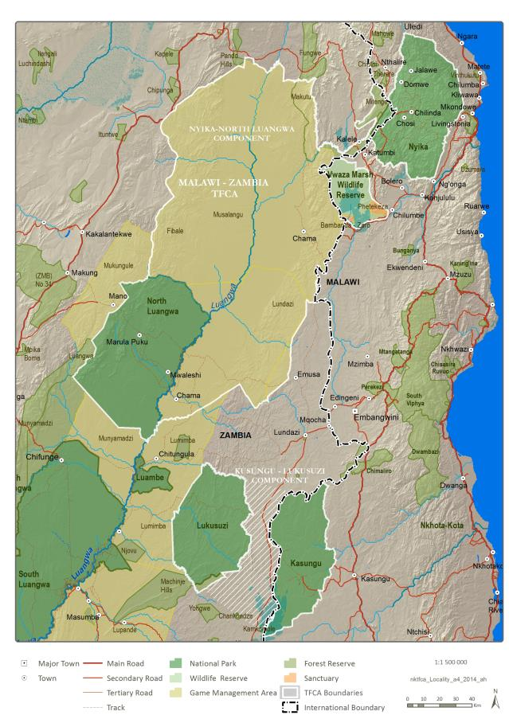
Map 1. Locality

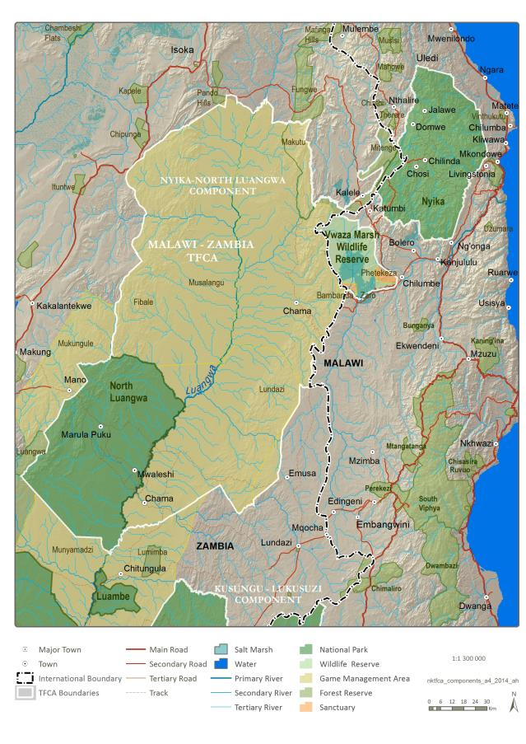
Define Boundaries through Stakeholder Consultation Process
Map 2. Integrated Development Plan Focus Area

Vision, Purpose and Objectives of the TFCA
The joint management vision for the Malawi-Zambia TFCA, and the various elements thereof, is “that they are managed collaboratively in a sustainable way with full stakeholder participation in a manner that fosters regional cooperation, cross-border biodiversity conservation, and contributes to socio-economic development of local communities”.
The primary purpose of this TFCA is for “harmonising policies, strategies and practices for managing shared natural resources that straddle the international borders of the two Partner States and deriving equitable socio-economic benefit through the sustainable use and development of their natural and cultural heritage resources”.
This foregoing is aligned with the SADC Protocol pertaining to TFCAs requiring the promotion of peace and security in the region and equitable sharing of benefits derived from the natural resources, largely through nature based tourism and resource utilisation, for present and future.
The strategic objectives of the Malawi-Zambia TFCA as set out in the MoU and draft Treaty are:
- Foster trans-national collaboration and co-operation between Malawi and Zambia in implementing ecosystem and cultural resource management through the establishment and development of the proposed TFCA
- Promote alliances in the management of biological and cultural resources and encourage social, economic and other partnerships among Governments and Stakeholders
- Enhance ecosystem integrity and natural ecological processes by harmonising wildlife management procedures across the international boundary and strive to remove artificial barriers or circumstances that inhibit natural movements of wildlife
- Develop frameworks and strategies whereby neighbouring communities can participate in, and tangibly benefit from, the management and sustainable use of natural and cultural resources that occur within the proposed TFCA
- Promote cross-border tourism as a means of fostering regional socio-economic development.
Specific objectives include:
- Maintain and manage the shared natural and cultural heritage resources and biodiversity of the Malawi-Zambia TFCA to support healthy and viable populations of wildlife species
- Promote and facilitate the development of a complementary network of protected areas within the Malawi-Zambia TFCA linked through corridors to safeguard the welfare and continued existence of migratory wildlife species
- Provide opportunities, facilities and infrastructure that shall transform the Malawi-Zambia TFCA into a premier tourist destination in Africa made up of a range of independent yet complementary and integrated sub-regional tourism development nodes
- Facilitate tourism across international borders in the Malawi-Zambia TFCA
- Develop and implement programmes that shall enhance the sustainable use of natural and cultural heritage resources to improve the livelihoods of local communities within and around the Malawi-Zambia TFCA and thus contribute towards poverty reduction
- Facilitate a healthy and competitive economic environment which promotes and enables public-private-community partnerships, private investment and regional economic integration
- Share experiences and pool resources and expertise across international borders in areas including indigenous knowledge, tourism management, border control, technology and renewable energy to facilitate development
- Promote and facilitate the harmonisation of relevant legislation, policies and approaches in natural and cultural heritage resources management across international borders and ensure compliance with international protocols and conventions related to the protection and sustainable use of species and ecosystems
- Build capacity for and within the Malawi-Zambia TFCA through training, enterprise development and mentoring programmes thus increasing the skills and knowledge associated with the management of natural and cultural heritage resources and facilitate stakeholder participation in the Malawi-Zambia TFCA planning and development processes
- Promote and facilitate the harmonisation of relevant legislation, policies and approaches in the area of transboundary animal disease prevention, surveillance and control within the Malawi-Zambia BIA TFCA
- Promote fundamental and applied scientific and multi-disciplinary research in order to increase the knowledge base for the Malawi-Zambia TFCA
- Mainstream emerging environmental issues and social paradigms, such as climate change and HIV/AIDS, in the overall development of the Malawi-Zambia TFCA.

Purpose of Integrated Development Plan
The purpose of the IDP is to serve as a public administration document giving strategic direction to the partner countries regarding the development of the TFCA in particular relating to:
- Alignment of constituent component plans
- Defining the extent of both the Malawi-Zambia TFCA
- Functional and effective institutional arrangements
- Sustainable financing for joint and cooperative actions
- Synergies between the legislation and policies utilised by the partner countries yet cognisant of the sovereignty of the individual countries
- Sustaining and restoring the ecosystem integrity of the Malawi-Zambia TFCA
- Integrated management and implementation of issues of joint interest and mutual impact
- Monitoring and evaluation of the further development and ongoing management of the Malawi-Zambia TFCA
- Implementation of joint development strategies, plans and programmes
- Providing benefits to the region and its people.
The term ‘integrated’ in the context of TFCA IDPs refers to the joint and collaborative approach towards TFCA development based on specific key performance areas – refer section 3.1.
This plan has a ten (10) year horizon that will be operationalised through five-yearly strategic implementation plans supported by detailed annual business plans guiding the activities of the various structures constituted as part of the Malawi-Zambia TFCA and falling within an integrated framework for performance review and assessment.
The preparation of the IDP was informed by inputs received through stakeholder consultation meetings (refer Appendix 2) and various existing documentation and reports, both relevant to the Malawi-Zambia TFCA as well as the individual country components (refer Appendix 3).

THE TFCA IN CONTEXT – HISTORY, KEY FEATURES AND ISSUES

History of the Conservation Areas
The first formal protection of the Nyika Plateau in Malawi was the proclamation of a Forest Reserve in 1948 to protect the southernmost population of juniper Juniperus procera trees in Africa. In 1951 the grasslands of the high plateau were protected under the Natural Resources Rules and hunting was prohibited. In the 1950’s the Colonial Development Corporation established a plantation of 542ha of pines, blue gums and wattle at Chelinda. The plantations were handed over to the Department of Forestry in 1958. In 1965 (after independence) the Malawi National Park, covering an area of 940km² of the Nyika Plateau, was proclaimed as Malawi’s first national park. The name was changed to Nyika National Park in 1969. In 1978 the park was considerably enlarged to its present size of 3,134km² by including the foothills lying south and north of the high plateau. This expansion was due to the critical role of the Nyika Plateau as a water catchment area on which much of northern Malawi depends for domestic consumption, irrigation and hydro-electric power generation. The expansion of the park boundaries also took account of the winter migration of large mammals, particularly roan antelope, eland and zebra, from the plateau to the adjacent woodlands and their return to the grasslands in the spring (refer Map 3).
The Kazuni Lake Game Reserve was proclaimed in 1941 and included the lake as well as all land within a radius of 5 miles (8km) around it. The legislation of that time prohibited hunting, but not settlement. In 1956 the Vwaza Marsh Controlled Area was proclaimed. This included the marsh and an area around it in which hunting was restricted to residents of the area and special licence holders. No restriction was placed on settlement. In 1963 the traditional authority under Chief Katumbi requested the development of the area for tourism. The Chief’s request led to the proclamation of Vwaza Marsh Game Reserve on 10 April 1977. All game reserves were later changed to wildlife reserves (refer Map 4).
The Lundazi Protected Forest Area was proclaimed in 1938, under Colonial legislation. Its purpose was to protect the escarpment woodlands east of the Luangwa Valley, along the international border, and the important water catchment on the western side of the Nyika plateau which gives rise to the Chire/Luwumba River. Lundazi is designated as National Forest No.24. In 1972 the northern sector of the Lundazi Forest Reserve that extended from the Chire or Luwumba Valley up the escarpment on to the Nyika Plateau was proclaimed as Nyika National Park (National Park No.12). It was described as being 80km² in extent.
In 2006 a fenced sanctuary - the Bambanda-Zaro Sanctuary - was established (1,948ha failing within the Lundazi FR in Zambia and 3,076ha within Vwaza March WR in Malawi – a total area of 5,024ha) as a holding area for translocated animals to settled in for an interim period of 3-5 years, facilitating compliance with veterinary requirements, enhancing and simplifying security and monitoring of the animals, and allowing for more direct management and, in time, utilisation of the animals.
The Makutu Forest Reserve is also a protected area of long standing, having been proclaimed as Protected Forest Area No.33 and is now also a National Forest. The Mitengi Forest Reserve was proclaimed as Protected Forest Area No.295.
The Musalangu GMA, proclaimed in 1971, was initially known as the Senga Controlled Hunting and is situated in the Eastern and Muchinga Provinces of Zambia respectively. The purpose of this GMA is to enhance the conservation, preservation and sustainable utilisation of the natural and heritage resources of the area for the improvement of the livelihoods of the local households through active community participation for the benefit of present and future generations (Zambia Wildlife Authority, n.d.) – refer Map 5.
As part of the GMA’s Management Plan, a community conservation area or Special Use Zone is proposed in the eastern parts of Musalanga GMA largely falling within Chief Kambombo’s area – the intention with the establishment of this area is to increase management effectiveness and efficiency of the protected area, reduce illegal resource use, increase the biodiversity status, provide increased livelihood benefits and improve connectivity to other protected areas in the TFCA, additionally to promote public private partnerships in the conservation of biodiversity and heritage resources in order to enhance nature tourism.
North Luangwa National Park was founded as a game reserve in 1938, and became a national park in 1972. Initially the wildlife suffered greatly from poaching, but recent years have seen poaching almost entirely stopped. It has generally suffered from a lack of investment and interest compared to the much more popular South Luangwa National Park, although its flora and fauna are very similar to its southern counterpart. The Luangwa Valley was seen as the stronghold of the black rhino in Zambia in the 1960s. It was estimated that NLNP was a refuge for between 500 – 2,000 animals before the onset of the poaching wave in the 1970s and 1980s. The Park was designated as a wilderness area and few wildlife scouts were stationed around the Park or entered it to carry out patrols during that time. This meant that its wildlife populations were particularly vulnerable to poaching and the last confirmed sighting of a black rhino in North Luangwa was in the mid‐1980s. In 2003, black rhinoceroses were re-introduced to the park, making this the only large Big 5 Park in Zambia (refer Map 6).
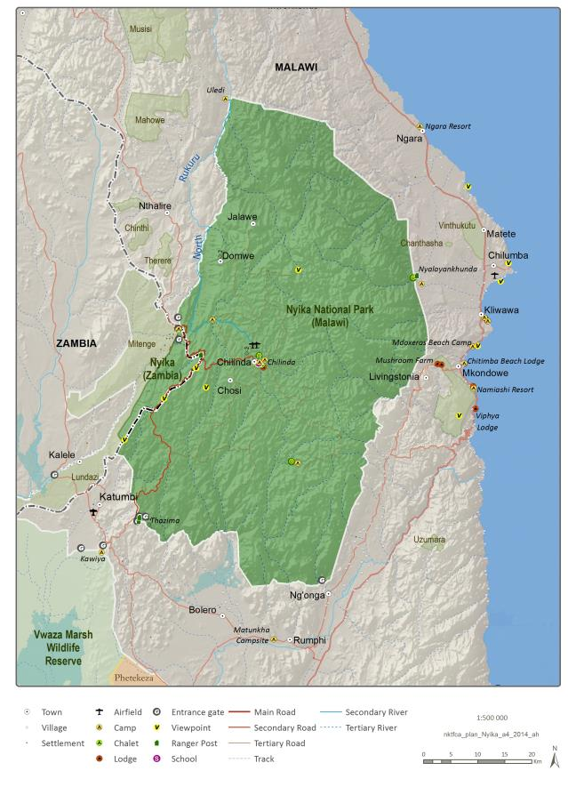
Map 3. Nyika National Parks
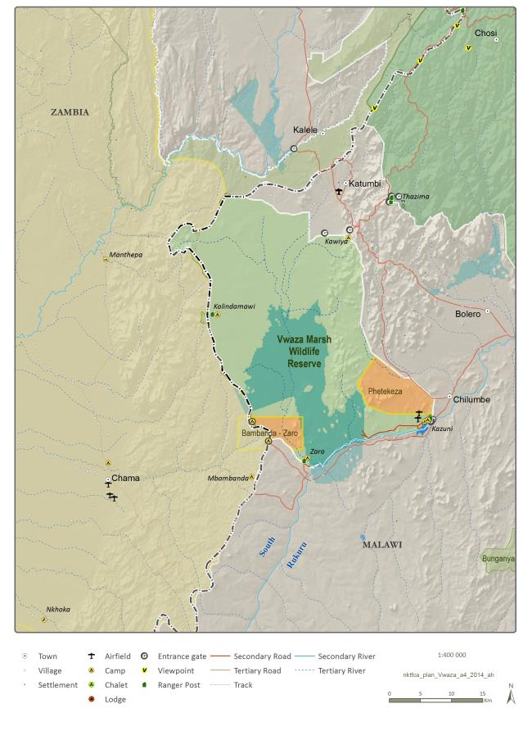
Map 4. Vwasa Marsh Wildlife Reserve
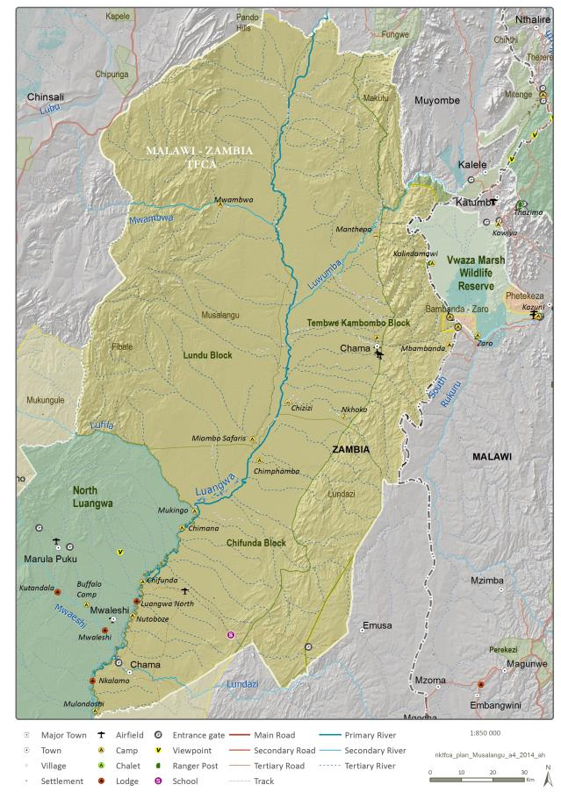
Map 5. Musalanga Game Management Area
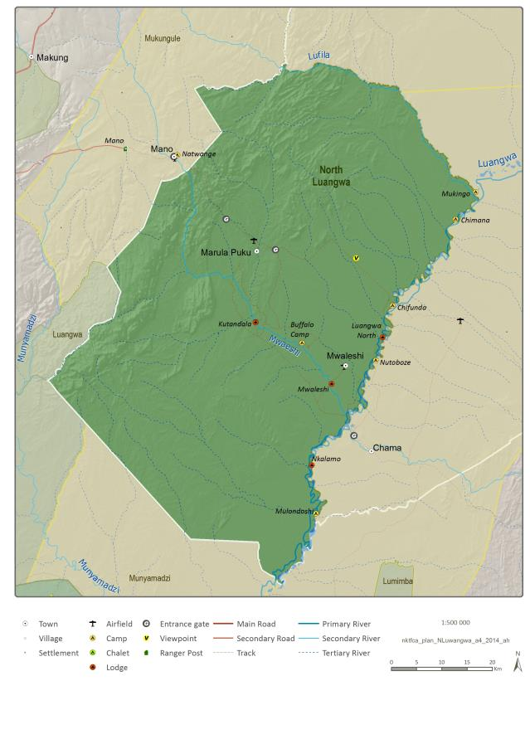
Map 6. North Luangwa National Park

Key Features and Issues
<Note: review figures – clearly define positive or negative issues>
The description of the key features of the Malawi-Zambia TFCA is based around understanding these features from a resource perspective, followed by a description of the business environment and then the current beneficiation environment. The description of each feature is directly linked to the issues pertaining to this feature.
The figure below illustrates the concept and a summary of the key features of the Malawi-Zambia TFCA, noting that this structure is used throughout the IDP for the various discussions regarding the attainment of the delicate balance between man, business and nature.
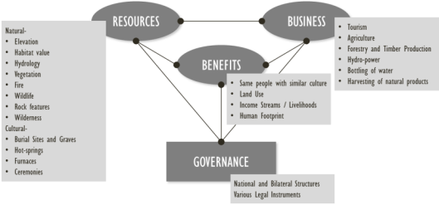
Figure 1. Summary of the Features of the TFCA
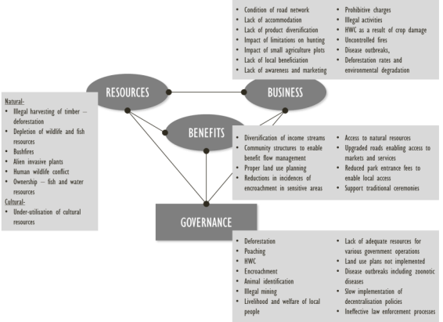
Figure 2. Summary of the Issues of the TFCA

Environmental Resources – Key Features and Issues
<Note: add more detail narratives on all maps and bring closer to text>
Due to the substantial and rapid elevation changes within the TFCA (refer Map 7), the ecological gradient from the north to the south of the TFCA is distinct, ranging from afromontane grasslands to Miombo and Mopane woodland.
As a result of the steep gradient, the Malawi-Zambia TFCA contains a high number of sensitive and high value habitats (refer to Map 9), that require conservation programmes to be implemented to ensure that the biodiversity associated with the landscape, as well as the resources, both natural and cultural, are appropriately protected.
This steep gradient ranging from the Nyika Plateau to the Luangwa Valley (North Luangwa National Park) also enables planning in respect of climate change mitigation along an ecological gradient.
The Malawi-Zambia TFCA is blessed with an abundance of natural and cultural resources, and its protected area network consists of five distinct and separate protected areas, all inextricably connected to one another. The main conservation areas, all IUCN (International Union for Conservation of Nature) Category II protected areas, are:
- The two Nyika national parks – Malawi and Zambia
- Vwaza Marsh Wildlife Reserve
- Musalangu GMA
- North Luangwa National Park.
<Notes:
- Add Forestry Reserves
- Review reference to IUCN Categories – lower categories
- Refer ‘open areas’>
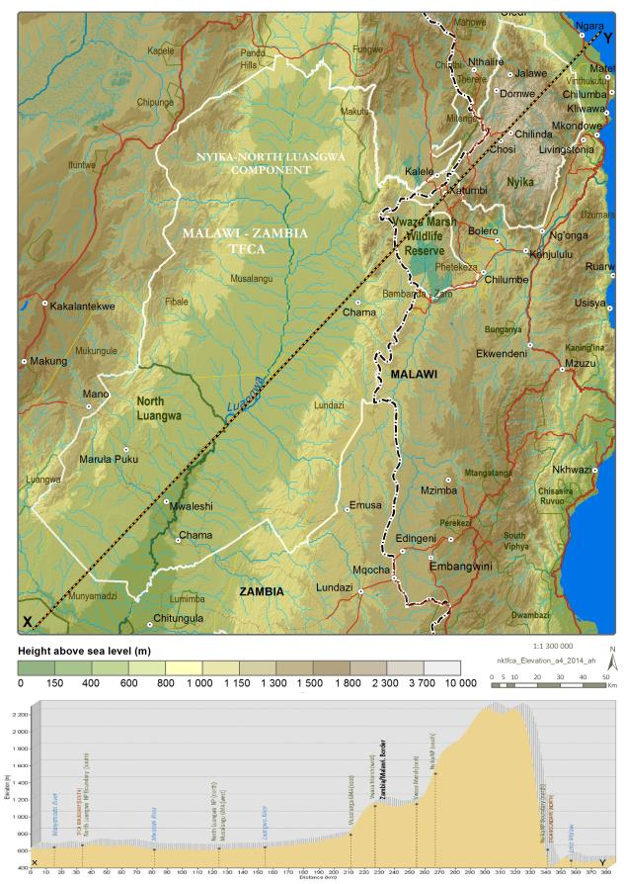
Map 7. Elevation with SW-NE Profile
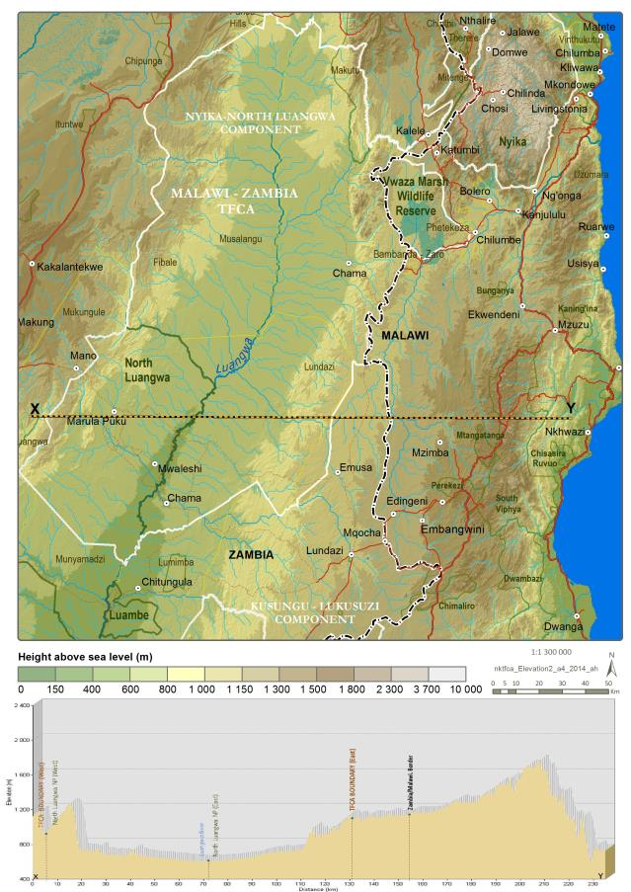
Map 8. Elevation with W-E Profile
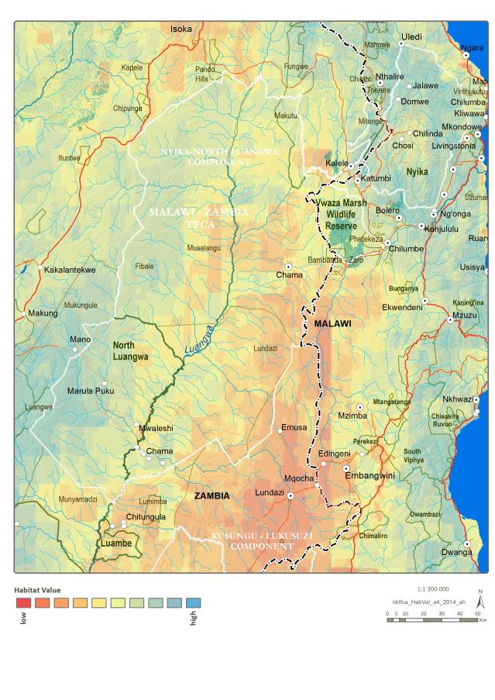
Map 9. Habitat Value
These protected areas form part of a larger conservation landscape stretching from Angola to Malawi. These landscapes provide connectivity for elephant as seen in the research undertaken by Roever et al (2013) regarding functioning connectivity within conservation networks delineating corridors for African elephant (refer Figure 3).
<Note: elaborate on above paragraph>
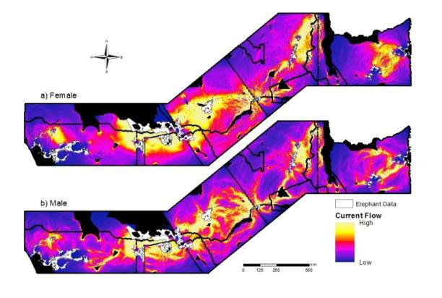
Figure 3. Current flow of elephant between Angola and Malawi
(Black regions indicate areas of zero flow.)
As a mountain catchment area, the Nyika Plateau has a significant role to play in providing opportunities to conserve several crucial ecosystem services, firstly, as a catchment for water production, and secondly, as a refuge area for rare and unique species of both fauna and flora (refer Map 10). The Nyika Plateau is an important source for several rivers and water courses of local significance such as:
- Chisanga Falls (Historical site)
- Hewe River (Irrigation, domestic use)
- Kaziwiziwi River (Domestic use)
- Lake Kaulimi (Cultural, water catchment)
- Lunyina River (Water catchment)
- Mhuju River (Irrigation, domestic use)
- Mwazisi River (Domestic use)
- North Rukuru River (Water catchment)
- Rumphi River - North and South (Water catchment)
- Ruviri River - Ng’Onga and Ruviri Nkhamunga (Irrigation, fishing, domestic)
- Ruviri River – Nkhamanga (Domestic use, irrigation)
- Wovwe River (Power, irrigation, water resource).
The Lunyina and Ruviri Rivers are sources for the Nkhamanga Water Scheme in Malawi.
All of these rivers are important as water catchment areas, as well as for fishing, and are relied on heavily by the local communities.
Other important water resources include:
- Lake Kazunigu (Domestic use, fishing)
- Luwewe River (Domestic use, fishing)
- Vwasa Marsh (Fishing, tourist attraction)
The North Luangwa National Park lies on the western bank of the Luangwa River bordered on the eastern side by the Muchinga Escarpment which rises over 1,000m from the valley floor. There are a number of tributary rivers running through the Park and into the Luangwa River which play an important ecological role in the area. The crystal-clear Mwaleshi River trickles down the escarpment in a series of small waterfalls. The rivers recede in the dry season, leaving many pools along the way, drawing wildlife from the bush to the river banks in search of water.
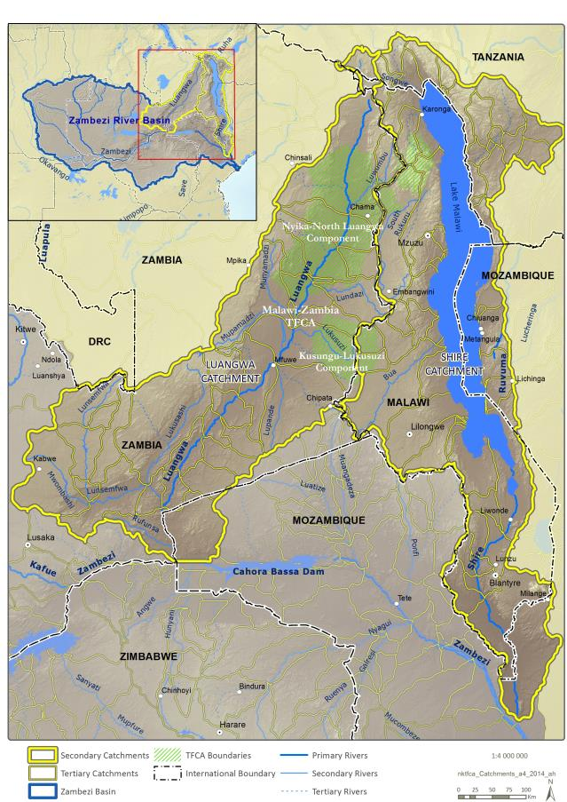
Map 10. Catchments

The broad vegetation types of the area are depicted in Map 11.
The Nyika Plateau is renowned for its wildflowers, especially orchids, of which there are both terrestrial and epiphytic species, of which there are 205 species, seven of which are known only from the Nyika plateau, and 11 localised orchid species. Additional wildflower species include dieramas, gladioli, protea and kniphofia. The Nyika National Park in Malawi is classified as a Centre of Plant Diversity. A SABONET (Southern African Botanical Diversity Network) report on the Nyika Plateau lists a total of 1927 species and subspecies, of which 33 are only found on the Nyika Plateau, and a further 13 species are only found there and on immediately adjacent mountains.
The main vegetation types of the Nyika Plateau are:
- Brachysteigia woodlands - Dominant in the southern foothills
- Evergreen Forests –
- Submontane (Ocotea-Ficalhoa) forest - Confined to the eastern escarpment where it occurs as the largest of the forest remnants
- Submontane (Entandrophragma) forests on the Zambia border which are floristically more abundant
- Montane (Juniperus) forest - Juniperus procera does not occur on the highest, most exposed parts of the plateau, but is found at 2,000–2,300m in sheltered valleys, specifically the Uyaghaya valley towards the south-east edge of the plateau, which signifies the southern limit of this species which is vulnerable to wild fires
- Broad-leaved montane forest – As the southern limit of Hagenia abyssinica, this vegetation type is found in patches in sheltered valleys, and it is thought that these once covered the entire plateau, yet since it is susceptible to wild fires started by lightning, poachers or accident the distribution is limited
- Montane Grassland - Covers approximately a third of the Plateau area and comprises hundreds of species of legumes, wildflowers and shrubs as well as over 90 species of short grass. A possible threat is the spread of Bracken Fern Pteridium aquilinum.
Of concern is that the four main forests on the Nyika Plateau - Juniper Forest; Mwenembe Forest; Bomwe Forest; and Nganda Forest – are all subject to deforestation, and that the montane grassland is subjected to excessive bushfire that changes the dynamics of this sensitive habitat.
A few exotic plant species occur on the plateau, including almost 570ha of pine plantation, planted between 1952–1958, occur on the Nyika Plateau at Chilinda, primarily Pinus patula, a few bluegums and Himalayan Raspberry (Rubus ellipticus) which could pose a threat to the habitat integrity in the area.
In contrast to the Nyika Plateau much of Vwaza Marsh Wildlife Reserve is located on low lying flat ground although the eastern side of the reserve is hilly. It is located to the southeast of the plateau and to the north of the floodplains of South Rukuru River and covers an area of 1,000km². The area is characterised by Mopane and Miombo woodland and marshy wetlands which attracts a significant number of birds to the reserve.
The vegetation within the Musalangu GMA, the Muchinga Escarpment, and North Luangwa National Park area ranges from Miombo and Mopane woodland to riverine forest, open grasslands and acacia thicket. Trees include the beautiful sausage tree, vegetable ivory palms, red mahogany and leadwood. Approximately 24% of NLNP consists of Muchinga Escarpment, which represents a large portion of the undisturbed escarpment Miombo vegetation in the area, including more than 1348 vascular plant species. The Park has also been identified as a Centre of Plant Diversity due to the global botanical importance of the protected area.
From refer to Map 12 it can be derived that fire seems to be prevalent throughout the focus area. Fire occurs naturally on the Nyika Plateau when grassland is ignited by lightning strikes. It must, therefore, be regarded as a natural dynamic of the Nyika ecosystem. The difficulty arises when fires are the result of human activity such as the smoking out of bees, or are deliberately set by poachers to attract game to the green flush of new grass that follows the burns. Controlled burning is, however, an important management tool in the Nyika grassland environment. Not only does the protection and rehabilitation of forests depend on fire control, but there is also a need to mediate the impact of fire intensity on grassland. It has also been suggested that there is a causal link between the intensity and frequency of fires and the supposed spread of the bracken Pteridium acquilinum. The spread of this fern renders large areas of limited use to grazing and browsing game animals, though it is used by some birds for shelter and nest sites. The short green flush of new grass that appears after burns is an important source of grazing for large mammals. Fire is also needed to stimulate the growth and flowering of numerous geophyte herbs and forbs that are an integral part of the grassland flora.
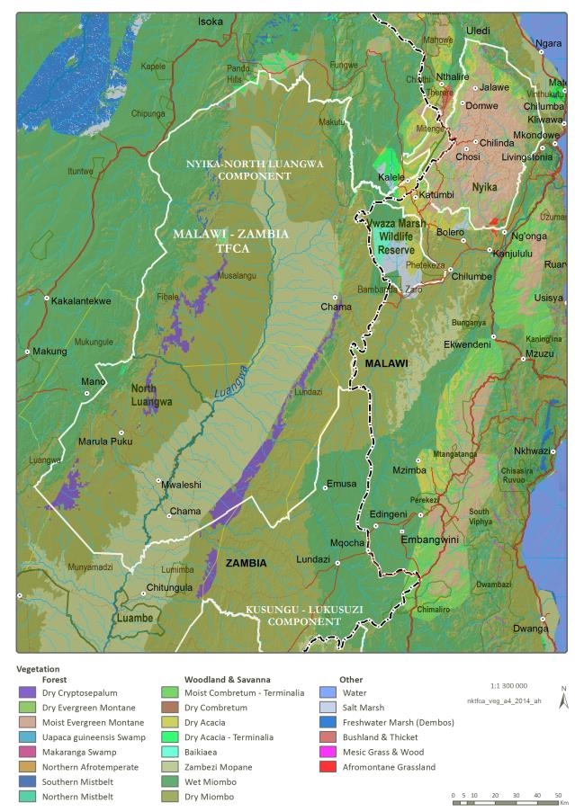
Map 11. Vegetation
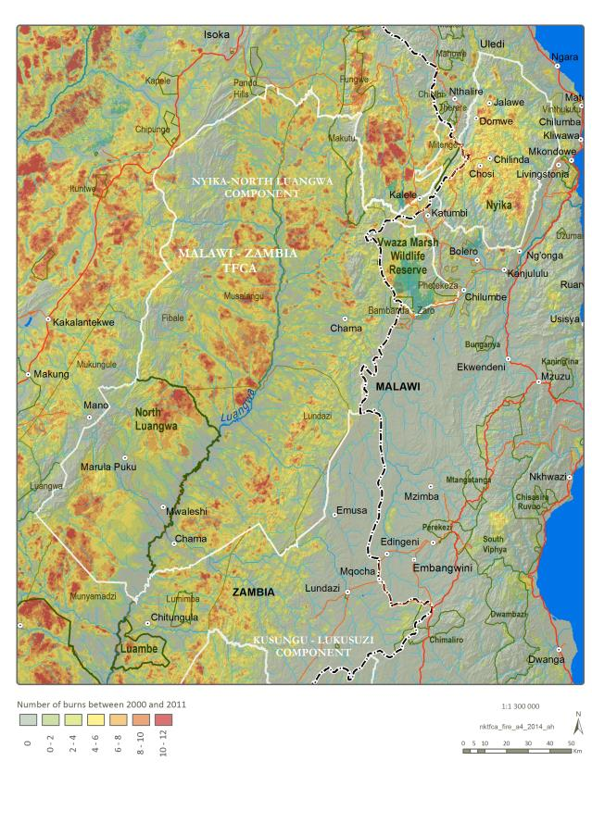
Map 12. Fire (2000-2011)
From a wildlife perspective, a variety of animals can be seen in the Nyika grasslands. Numbers and species vary depending on the time of year, with the Nyika national parks having important populations of roan, eland, Crawshay's zebra, southern reedbuck, bushbuck, warthog, spotted hyaena and side-striped jackal. Elephant can be seen at times and leopard can be seen in the daytime owing to the temperate climate.
Rare and endemic species in the Nyika National Park is the only known Malawi locality of the Greater Dwarf Shrew Suncus lixus and the Lesser Dwarf Shrew Suncus varilla, as well as a very rare bat Plerleirotes anchietae and two species of vlei rats, that are endemic to montane areas from the Nyika to Ethiopia (Tanganyika vlei rat Otomys typus and Kemps vlei rat Otomys deni).
Within Vwaza Marsh Wildlife Reserve, the animal species and numbers vary from season to season as they cross the border with Zambia, entering specifically the Musalangu GMA and NLNP. Typically the reserve has large herds of buffalo and elephants, and a large variety of antelope including roan, greater kudu, Lichtenstein's hartebeest, eland and impala. Lake Kazuni is located in the reserve and supports a notable hippo population.
North Luangwa National Park is the only protected area within the Malawi-Zambia TFCA that supports the Big 5, and is one of only a few within the SADC region. It also has Cookson’s Wildebeest and Crayshay’s Zebra. High concentration of large mammals such as buffalo, hippo, wildebeest, zebra, lion and hyaena are the major attraction in North Luangwa National Park, augmented by the presence of endangered and endemic species, such as black rhino, Cookson’s wildebeest and wild dog.
Due to the relative abundance of wildlife throughout the Malawi-Zambia TFCA the occurrence of Human Wildlife Conflict (HWC) incidence is also high. This is often a result of encroachment, unseasonal burning disturbing wildlife movement patterns, and the lack of effective mitigation measures.
Both the Nyika and North Luangwa components of the Malawi-Zambia TFCA are listed as IBAs (Important Bird Areas). Notable birdlife in this area include Goliath Herons, Openbill Storks and the rare White-winged Starling, while approximately 430 species of birds have been recorded on the Nyika Plateau of which around 60 are vagrants or very rare. Denham’s Bustard (Neotis denhami) are resident on the plateau grassland with occasional sightings of groups numbering 15-24. Also endemic are Red-winged Francolin Francolinus levaillantii crawshayi, first collected in 1895, and other special birds such as Pallid Harrier, Augur Buzzard, Mountain Cisticola, Mountain Marsh Whydah, and Blue Swallow (seasonal: August to April).
Three species of global conservation concern breed on the Nyika:
- Blue Swallow (Hirundo atrocaerulea) – Nyika National Park supports 10% (300 pairs) of the total breeding population. Healthy montane grasslands are critical for their survival
- Churring Cisticola (Cisticola njombe), also dependent upon healthy montane grasslands
- Wattled Crane (Grus carunculatus), while about 12 breeding pairs were recorded in 1986, it is now thought to be only 3 breeding pairs.
Also of conservation concern are the:
- Pallid Harrier (Circus macrouris)
- Lesser Kestrel (Falco naumanni)
- Great Snipe (Gallinago media)
- Greater Double-collared Sunbird (Nectarinia afra).
Listed for the Nyika Plateau, there are 47 reptile species, of which three species are endemic, and at least 15 types of frogs and toad, mostly favouring the damp and cool dambos, of which two are endemic to the area:
- Nyika Variable Skink Mabuya varia nyikae
- Hilda’s Skink Mabuya hildae
- Goetz’s Nyika Chameleon Chamaeleo goetzi nyikae
- Black-Striped Sedge Frog Hyperolius quinquevittatus merdensi
- Nyika Dwarf Toad Bufo taitanus nyikae.
The abundant number of crocodile in the Luangwa River, especially along the Luangwa – Mwaleshi Confluence is also an attraction to the area.
Lake Kaulumi and the three man-made dams, together with the four major rivers that rise on the Nyika Plateau and supply the northern region before flowing to Lake Malawi, as well as numerous streams, provide habitats for 27 indigenous species of fish. Most are found in the lower reaches of the rivers, the most important being Lake Salmon Opsaridium microlepis (known locally as Mpasa) that spawn in the clean waters of the North Rukuru river.
The only indigenous species on the plateau itself is the Mountain Catfish Amphilius platychir, while the exotic Rainbow Trout Salmo gairdnerii were introduced.
Despite very little being known about the 1000 plus collected and identified insects of the Nyika Plateau, the area supports 223 species of butterflies of which around 120 are forest species. At least 13 species are endemic, including:
- Charaxes dowsetti
- Charaxes nyikensis
- Papilio thuraui cyclopis
- Mylothris crawshayi crawshayi
- Axioceres karinae
- Lepidochrysops chalceus
- Lepidochrysops nyika.
Throughout large areas of the Malawi-Zambia TFCA, the natural resources are utilised by local people and communities. This use varies from nutritional, functional, and cultural to spiritual. Many of the plants are utilised for food and include tubers (Chinaka), mushrooms, wild fruits (Masuku) and palms, while other are used for construction– thatching, timber and poles – including grass in the area, which is also used for grazing of domestic livestock. Illegal harvesting of timber has been raised as a concern in the area.
Two rock features have specific cultural value - Fingila Rock and Ng’Anjo Rock (furnace) – both of which have got value for use within cultural tourism aspects of the TFCA.
Fossil bearing rocks occur in the Luangwa Valley and have been documented by a series of studies dating as far back as the 1930’s. The following are among the fossil bearing rock sites that exist within NLNP:
- Locality 9 of the 1974 expedition which lies on the Musina River, about 2 km west of Marula-Puku and is rich in dicynodont, gorgonopsid and pareiasaur specimens of the Madumabisa mudstone;
- The exceptionally well preserved silicified wood between the Lufwashi and Mulondoshi Rivers. Whole petrified tree trunks and specimens showing such details as insect infestations are abundant;
- Madumabisa mudstone along the Mulondoshi River; and
- Locality 10 on the Lokokwa River is an exposure of the middle Triassic Ntawere formation consisting small pieces of fossilized wood and a few fragments of bone on a piece of breccia.
Despite the tourism value, the full spectrum of wildlife – mammals, birds, reptiles, fish, and insects – is exploited to augment food security and commerce. Most of the mammals are hunted, either commercially, recreationally or traditionally, and this situation has led to depletion in most of the wildlife populations. Poaching of wildlife has been raised as an issue that must be addressed.
Fish resources are heavily utilised and concerns have been raised regarding overfishing, not abiding to the fish bans, trapping of fish during the breeding season, the use of mosquito nets and chemicals, and perceptions regarding the ownership of fish and water resources.
Honey, as well as honey bees, are a valuable resource that is extensively utilised in the Malawi-Zambia TFCA, for both food and as an income generation activity.
Cultural heritage resources, such as hot springs, graves, and burial sites are spread throughout the entire Malawi-Zambia TFCA. Among the identified cultural and archaeological resources of NLNP are Museba and Mboloma. Museba is a site along the Mwaleshi River near the falls, and this is the location that the subjects of Chief Mukungule used to embalm their chief for about a year in preparation for burial. Mboloma is a site along the Lubanga River where the Bisa of Mukungule still visit on a yearly basis to perform their traditional rites to appease their ancestors and ask for continued peace and prosperity for the whole tribe.
Due to the remoteness and undeveloped nature of the entire region, the Malawi-Zambia TFCA offers one of the finest wilderness experiences in Africa. North Luangwa National Park specialises in offering walking trails based on the principle of restricted development and use of vehicles and a road network that is limited. Other areas within the TFCA offer similar wilderness experiences. Wilderness is a rare and threatened resource that should be identified, managed and protected (refer Map 13).
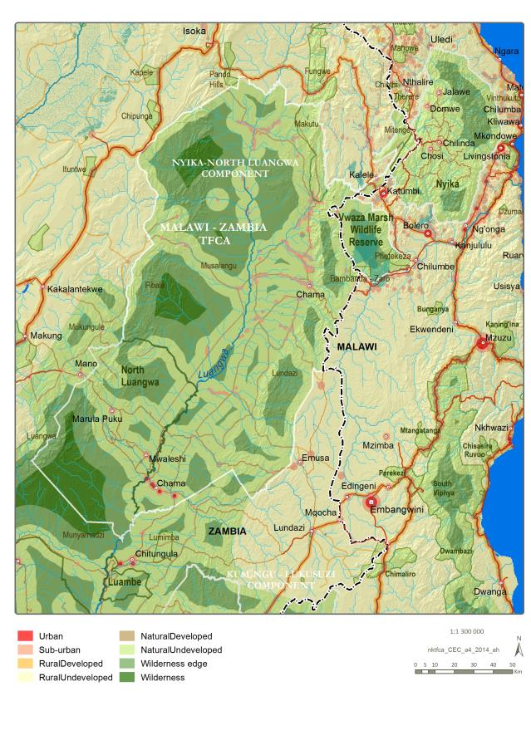
Map 13. Current Environmental Character

Table 2: Current Environmental Character Descriptions
Character | Protected | Impacts | Buffer (km) | Notes
Wilderness | Y | N | 15 | Wilderness start 15km from impact zones
Wilderness: edge | Y | N | 5 | Wilderness edge start 5km from impact zones
Natural: undeveloped | Y | N | -
Natural: developed | Y | Y | Extent | Infrastructure within the Protected Area
Rural: undeveloped | N | N | Extent
Rural: developed | N | Y | Extent | Subsistence farming used as main indicator
Sub-urban | N | Y | 1 | Buffer around existing urban areas
Urban | N | Y | 2

Business or Economic Environment – Key Features and Issues
Tourism, safari hunting, agriculture, bee keeping, mushrooms, fishing, forestry and timber as well as hydro-electric power generation and bottling of water have all been raised as economic opportunities within the Malawi-Zambia TFCA.
Map 18 illustrates aerial and road access to the focus area, along with the location of the various Ports of Entry.
Despite being a vast area, with numerous attractive areas, characterised by the occurrence of wildlife, beautiful scenery and wilderness, as well as the highly restricted distributions of birds and other species on the Nyika Plateau making the plateau a key birding and special interest destination in Africa, the Malawi-Zambia TFCA is relatively underdeveloped regarding tourism facilities.
The main tourism facilities are Chilinda Camp in the Nyika National Park, Malawi and within or directly adjacent to NLNP in Zambia the following:
- Mwaleshi camp
- Buffalo Camp
- Luangwa North Camp
- Unna’s Camp
- Chifunda Community Camps.
North Luangwa National Park is renowned for walking safaris, based on the abundance of wildlife as well as the wilderness character of the area.
From a tourism development perspective, the TFCA can be divided into several development blocks, with subsequent concession areas. These include, inter alia:
- Nyika Plateau – 5
- Vwaza Marsh – 3
- Musalangu GMA – 5 (refer below)
- North Luangwa –5 existing.
Tourists, largely due to poor road conditions and difficult terrain and inaccessibility, rarely visit Vwaza Marsh Wildlife Reserve yet a concession area and additional campsites have been identified.
The rates for access and accommodation within the protected areas affect the use of the national parks and reserves by local people. This has been raised as an issue requiring addressing, so that the protected areas can become more accessible to affected and host communities.
Another issue that has been raised by stakeholders is the lack of awareness and marketing of lesser known resources such as the Chisanga Falls, Lake Kazuni, several hot springs, sites of cultural heritage significance, sites with high levels of endemic, rare or unique species and areas that have potential for photographic safaris such as Tembwe; Chikwa; and the Chama High Hills areas, specifically Mphalansenga and Mbambanda.
Safari hunting has been a viable option within the Malawi-Zambia TFCA, with the Musalangu GMA being the primary focus for this. Five concession blocks have operated within this area and are:
- West Musalangu (6,184km²)
- East Musalangu (6,743km²)
- Chikwa (3,102km²)
- Chifunda (1,676km²).
Concerns have been raised regarding the impact of restrictions on this as a livelihood option for affected communities, with concomitant increases in poaching as a mitigation strategy utilised by communities.
The area is characterised by mainly small agricultural plots, with significant impact on the areas surrounding the Nyika National Park and Vwaza Marsh Wildlife Reserve. Bee-keeping, mushroom collection and fishing are all agricultural and resource utilisation options utilised by the communities affected by the protected areas.
Forestry and timber production are options for certain areas of the TFCA, yet concerns have been raised about illegal timber harvesting causing localised deforestation and degradation, as well as the lack of benefits to local communities where timber harvesting and production are legalised.
Suggestions have been made to use some of the water resources to generate hydroelectricity or for bottled water given the purity of the water resources.
Issues that have been raised regarding the encumbrances pertaining to the economic environment include the condition of the road network, lack of accommodation, lack of product diversification, lack of local benefits, lack of awareness and marketing, prohibitive charges, and illegal activities. These issues are exacerbated when considering aspects such as HWC as a result of crop damage, uncontrolled fires, disease outbreaks, deforestation rates and environmental degradation.
<Notes:
- Elaborate on illegal activities
- Add Vwasa Marsh – Kasuni Lodge>
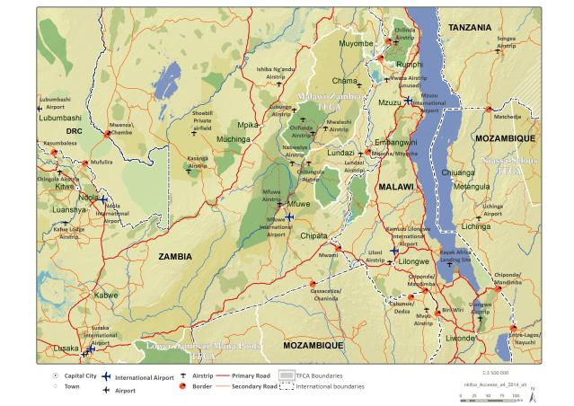
Map 14. Access Points and Main Routes

Benefit or Social Environment – Key Features and Issues
The land use within the Malawi-Zambia TFCA is largely compatible, characterised by a similar social capital consisting of similar groups of people, similar culture, and similar issues, yet with wildlife and ecotourism making up the bulk of the regional economy, built off a base existing of the Nyika national parks and NLNP, as well as Vwaza Marsh Wildlife Reserve. The intervening area, mainly consisting of the Musalangu GMA is where the most diversified economy exists, with aspects such as livestock farming, agriculture, fishing, bee-keeping, timber, safari hunting and tourism all being utilised as income streams.
The communities situated within the GMA have largely relied on income from safari hunting, rather than diversifying income streams, and the recent changes to the wildlife management policies within Zambia have affected this income stream. Poverty is prevalent, often exacerbated by drought, with few viable options other than ecotourism to truly influence the regional economy.
However, the potential of many resources, such as the springs, some of which are hot, such as those at Kalunguvu – Sitwe; Chipyuzi – Mphyahakunda; Kamimbili – Katangalika (Tembwe), and Kapisha – Chilubanama remains untapped due to deforestation, the lack of management and development. Heritage sites, such as the graves at Lenshina – Chama Day School; Kalimatundu – Thembwe, and Soyo Burial – Kambombo / Mphundu, suffer similarly, and are being impacted on by insensitive development.
Traditional ceremonies, such as the Kwenje – Senga (Vimbuza / Luzamba); and the Zimphungu are not utilised to the benefit of the region, due to a lack of support from influential local people, and a lack of awareness and marketing of the ceremonies to tourists.
Map 15 illustrates the degree of human influence over the area, evaluated in terms of population, travel routes, land use, and lights. The areas of greater impact lie largely within Malawi with lesser impacts within the Zambian component.
Issues that have been raised by stakeholders regarding communal needs include:
- The need for diversification of income streams to include ecotourism as a way of offsetting reliance solely on safari hunting
- Establishment of community structures to enable benefit flow management from tourism and related activities
- Proper land use planning and implementation to ensure that no conflicting land use occurs in key tourism areas
- Reductions in incidences of encroachment by development in sensitive areas
- Access to resources such as thatching grass; firewood, mushrooms, fish, and wildlife for protein
- Upgraded roads within the broader area to enable access to markets and services such as electricity and clean water, as well as schools and clinics
- Reduced park entrance fees to enable local access to these national assets for both recreational and educational purposes, as well as ceremonial events
- Support for traditional ceremonies.

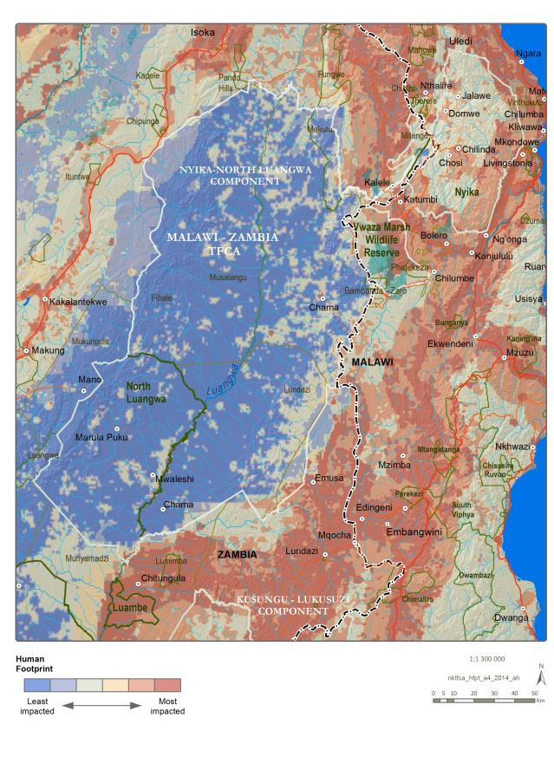
Map 15. Human Footprint

Governance Environment – Key Features and Issues
A key feature of the Malawi-Zambia TFCA is the presence of bilateral and national institutional structures.
The interim institutional framework for the Malawi-Zambia TFCA until the Treaty is signed is set out in Figure 4– the responsibilities of the respective entities are set out in the MoU. Currently, three different levels of institutions are involved in the management of various components of the TFCA. At the bilateral level, two exist, namely the BMC, as well as the BTC, which can establish Specialist Working Groups. An IC is responsible for the coordination and administration of these two committees.
<Notes: refer to Joint Steering Committee established for Nyika Project>
At the national level, each country has a National TFCA Committee consisting of representatives from the conservation agency and other stakeholders.
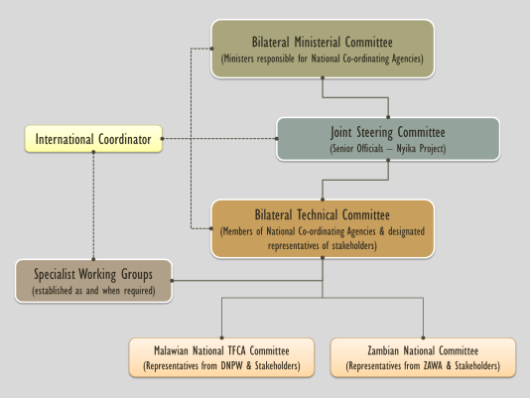
Figure 4. Interim TFCA Institutional Framework in terms of the MoU
In Malawi, the DNPW, of the Ministry of Information, Tourism and Culture, is responsible for the management of the Nyika NP and Vwaza Marsh WR. Direct management is carried out by senior staff based within the protected areas under the supervision of the divisional office at Thazima in the Nyika NP.
In Zambia, North Luangwa National Park, Nyika NP and Musalangu GMA fall under the jurisdiction of ZAWA, a parastatal institution under the Ministry of Tourism and Arts. Direct management is carried out by the Chama Area Management Unit based at Chama, and the Bangweulu Area Management Unit, under the supervision of the Senior Warden based at Mfuwe and Mpika respectively, which are in turn supervised by ZAWA Head Quarters based at Chilanga.
The national forests and forest reserves fall under the administration of the Forestry Department. In the case of Lundazi FR, this is the Provincial Office for the Eastern Province in Chipata as well as the Lundazi and Chama District Offices. The Mitenge FR, Makutu FR and several other smaller forest reserves that are within the Musalangu GMA fall under the jurisdiction of the Northern Province office of the Department of Forestry based in Chinsali. There are no resident departmental staff members in any of the forest reserves.
Both countries have district level committees consisting of traditional leaders, councillors, politicians and government officials, enabling the addressing of issues at the lowest level possible within each country. This approach truly allows implementation of projects to happen in a decentralised manner.
Issues that have been raised by stakeholders from this group include:
- Deforestation
- Poaching
- HWC
- Encroachment
- Animal identification
- Illegal mining
- Livelihood and welfare of local people
- Lack of adequate resources for various government operations
- Land use plans not implemented
- Disease outbreaks including zoonotic diseases
- Slow implementation of decentralisation policies
- Ineffective law enforcement processes, often based on insufficient evidence.
<Note: refer to the various management plans for the respective PAs and add table – year completed, period covered, responsible authority – NB – no plans for Forestry Reserves...>
Table 3. Status of Management Plans for the Protected Areas of the Nyika-North Luangwa Component
partner country | PROTECTED AREA | Year Completed | period | responsible authority
Malawi | Nyika National Park | Under review |  | National Parks and Wildlife Department
Malawi | Vwaza Marsh Wildlife Reserve | Under review |  | National Parks and Wildlife Department
Zambia | Fibale Forest Reserve | - | - | -Forestry Department
Zambia | Lundazi Forest Reserve (a section of) | - | - | Forestry Department
Zambia | Nyika National Park | - |  | Zambia Wildlife Authority
Zambia | North Luangwa National Park | Expired in 2014 |  | ZAWA
Zambia | Makutu Forest Reserve | - | - | Forestry Department
Zambia | Mitengi Forest Reserve | - | - | Forestry Department
Zambia | Musalangu Game Management Area | 2014 | 10 | ZAWA

The international and regional background to the obligations and responsibilities that must be exercised and demonstrated in the management of the Malawi-Zambia TFCA are contained in the following instruments, recognising that both Partner Countries are signatories to these:
At an International Level-
- The African Convention on the Conservation of Nature and Natural Resources (Algiers, 1968)
- UNESCO’s Man and the Biosphere Programme (1970)
- The Convention on the Conservation of Wetlands of International Importance (Ramsar 1971)
- The World Heritage Convention (Paris, 1972)
- The Convention on International Trade in Endangered Species of Wild Fauna and Flora (Washington, 1973)
- Convention on Biological Diversity (Rio de Janeiro, 1992)
- The United Nations Framework Convention on Climate Change (New York 1992)
- The United Nations Convention to Combat Desertification (Paris,1994).
At a Regional Level-
- The Southern African Development Community (SADC) Treaty (1992)
- SADC Wildlife Policy and Development Strategy (1997)
- SADC Environment and Sustainable Development Policy and Strategy (1998)
- SADC Protocol on Trade (1996)
- SADC Protocol on the Development of Tourism (1998)
- SADC Protocol on Wildlife Conservation and Law Enforcement (1999)
- The revised SADC Protocol on Shared Water Courses (2000), and the SADC Protocol on Forestry (2002).
While Malawi and Zambia are a party to most of the above instruments the extent to which their tenets have been absorbed in domestic legislation and practice may vary.
National instruments in Zambia and Malawi are set out in Table 4.
Table 4. Relevant National Policy and Legislation
<Note: Chris Kaoma to provide Zambian update>
theme | MALAWI |  | ZAMBIA
theme | legal instrument | mandate | legal instrument | mandate
Environmental Management | Biosafety Act  Plant Protection Act  Environmental Management Act  National Environmental Policy, 2004  Noxious Weeds Act | Environmental Affairs Department  Agriculture Department | Environmental Protection and Pollution Control Act  Noxious Weeds Act | Zambia Environmental Management Agency
Wildlife | National Parks and Wildlife Act (and National Wildlife Policy, 2000) | DNPW | National Parks and Wildlife Act  International Game Park and Wildlife Act  Fencing Act | ZAWA
Forestry | Forestry Act  National Forestry Policy | Forestry Department | Forestry Act | Department of Forestry
Water | Water Resources Act  Water Resources Management Policy, 1994 | Ministry of Water and Irrigation Development | Water Act | Ministry of Mines, Energy and Water Development
Veterinary Services | Control of Diseases of Animals Act  Meat and Meat Products Act  Animal Care and Protection Act | Ministry of Agriculture and Livestock Development | Veterinary Surgeons Act | Ministry of Agriculture and Livestock
Safety and Security | Police Act | Malawi Police Service | State Security Act | Office of the President
Immigration and Customs | Immigration Act  Control of Goods Act | Department of Immigration | Immigration and Deportation Bill | Ministry of Home Affairs
Revenue | Customs and Excise Act | Malawi Revenue Authority | Zambia Revenue Authority Act | Zambia Revenue Authority
Culture and Heritage | Cultural Policy | Department of Culture | National Heritage Conservation Commission Act  National Museums Act | Ministry of Tourism and Arts
Traditional Affairs | Chiefs Act  Customary Land Development Act | Ministry of Local Government  Ministry of Land and Housing | Chiefs Act | Ministry of Chiefs and Traditional Affairs
Land Use and Settlement | Land Act  Land Policy, 2002  National Land Resources Management Policy and Strategy, 2000  Town and Regional Planning Act | Ministry of Land and Housing | Lands Act  Town and Country Planning Act  Local Government and Housing Act | Ministry of Lands, Natural Resources and Environmental Protection
Tourism | Tourism and Hotels Act | Department of Tourism | Tourism Act | Ministry of Tourism and Arts
Agriculture and Livestock | Fertilisers, Farm Feeds and Remedies Act  Special Crops Act  Policy on Livestock, 2006 | Ministry of Agriculture and Livestock Development | Agricultural Lands Act | Ministry of Agriculture and Livestock
Mining | Mines and Minerals Act | Ministry of Mines | Mines and Minerals Act | Ministry of Mines, Energy and Water Development
Fisheries | Fisheries Conservation and Management Act  National Fisheries and Aquaculture Policy, 2001 | Department of Fisheries | Fisheries Act | Ministry of Agriculture and Livestock
Enterprise Development | Public Partnership Policy | Ministry of Economic Planning and Development | (Trade development, investment promotion, enterprise restructuring, development of green fields’ projects, small and enterprise development, trade and industry fund management, and contributing to skills training development) | Ministry of Commerce, Trade and Industry  Zambia Development Agency

TFCA PERFORMANCE ASSESSMENT

TFCA Development
The Malawi Zambia TFCA is regarded as a central TFCA within SADC, where the functioning of the ecosystem that supports the resources of two important national parks – Nyika and North Luangwa - transcends international boundaries. The TFCA partner countries believe that through collaboration between the various conservation agencies and authorities the conservation objectives of the area can be attained more effectively and efficiently.
Clear direction regarding and reporting on the efficacy of the various interventions undertaken within the Malawi-Zambia TFCA becomes essential not only for the Governments, but also for international cooperation partners, donors, resource managers, affected communities and investors.
For this reason a TFCA Development approach is followed as the basis for the IDP – both in terms of assessing progress to date as well as planning the actions required to address the specific objectives of the TFCA.
The TFCA Development approach, based on general best practice within other SADC TFCAs, consists of eight Key Performance Areas (KPA), and within each KPA various indicators have been identified to guide the TFCA development process (refer Figure 6)-
KPA 1 – Joint Planning: Collective planning of the TFCA and the alignment and implementation of the individual TFCA component plans
KPA 2 – Institutional Arrangements: Functional and representative TFCA institutional arrangements and structures
KPA 3 – Sustainable Financing: Securing sufficient funding to implement the actions to attain the envisaged TFCA objectives
KPA 4 – Policy Harmonisation: Synergy between operational policies utilised by the Partner Countries, cognisant of sovereignty
KPA 5 – Sustaining and Restoring Landscape Dynamics: Sustaining ecosystem integrity and landscape dynamics (both cultural and natural) where intact and restoring where fragmented
KPA 6 – Tourism Development: Aimed at unlocking the inherent potential within TFCAs through tourism development, thereby broadening the constituency base for TFCAs while exploiting the economic and social benefits associated with this as a land use option, highly compatible with conservation and regional development
KPA 7 – Community Development: Ensuring tangible and equitable benefits to communities that host conservation initiatives
KPA 8 – Integrated Management: Joint and cooperative (‘park-to-park’) management between the Partner Countries’ conservation agencies.
The first four KPAs - (1) to (4) are usually the responsibility of senior government officials, while KPAs (5) and (6) are usually addressed by conservation managers within the partner countries. KPA (7) is addressed comprehensively by the TFCA partner countries aimed at creating a conducive environment within which business can unlock the potential within TFCAs. KPA (8) - Benefit Flow Management – is addressed by senior officials based on information gathered by the various sectors – resource management, business and affected communities, and addresses the reporting on the benefits emanating from TFCA development.
Intentionally, TFCA governance, is not defined, and it is deliberately broad so as to capture all of the political, social and economic goods and services that affected communities and stakeholders have the right to expect from the governments regarding conservation development in an economically and socially acceptable manner. It can be summarised into the four over-arching environments - each making up a crucial component regarding the sustainability of the Malawi-Zambia TFCA, with the pivot being the actions of the two governments (refer to Figure 5).
The main objective with the use of the TFCA Development approach as the basis of the IDP is thus to:
- Establish the progress in the establishment and development of the Malawi-Zambia TFCA (refer subsection 3.2)
- Identify factors that have retarded progress in establishing and developing the TFCA
- Establish targets to guide actions towards further developing the TFCA.
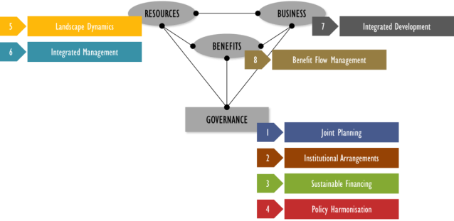
Figure 5. TFCA Governance and KPAs
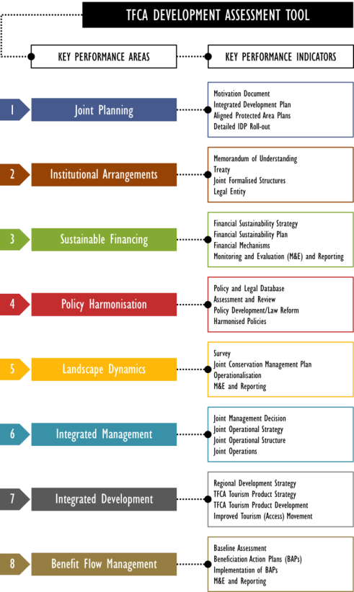
Figure 6. Performance Assessment Framework

Measuring Malawi-Zambia TFCA’s Performance
Since the signing of the MoU, some of the key achievements to date include the following:
- The MoU created an institutional framework within which the development of the TFCA would take place (refer Section 2.3.1 for further details) – various meetings were held by the Bilateral Ministerial Committee (BMC), Bilateral Technical Committee (BTC), Bilateral Working Group and local stakeholders
- Key documents have been prepared including:
- Nyika TFCA Joint Management Plan, 2007 (approval by the BMC)
- Nyika TFCA Integrated Tourism Development Plan, 2006 (approval by the BMC)
- Project Plans for Nyika TFCA and Kasungu-Lukusuzi TFCA
- Draft Treaty cleared by the respective Ministries of Justice and pending cabinet submission <amend if necessary before finalising the IDP>.
- Sourcing of funding (refer Table 5) and concomitant implementation – key activities include:
- Establishing dedicated institutional arrangements for implementation of specific projects (refer Nyika TFCA Project)
- Recruitment of key project staff members
- Staff training in among other monitoring and evaluation; protected area management, and financial management
- Procurement of office furniture and stationery, information and communication technology equipment, vehicles, field equipment and uniforms
- Civil works including water augmentation; boundary fence clearing; airstrip maintenance; road maintenance and rehabilitation; staff housing maintenance and construction; gate maintenance, installation of joint radio communication network and construction of an operations room for the Kasungu-Lukusuzi TFCA.
- Operations including:
- Joint law enforcement to combat poaching in the Nyika national parks
- Wildlife restocking of Nyika National Park and Vwaza Marsh Wildlife Reserve
- Animal population monitoring
- Research
- Firebreaks and burning
- Surveys in the Chama Community Conservancy area and Musalanga GMA.

Table 5. Funding and Current Projects
source of funds | APPLICATION (Projects) | AMOUNT (US$)
source of funds | APPLICATION (Projects) | total | spent | remaining | committed
Global Environmental Fund (GEF) Malawi | Institutional and Planning Framework  Sustainable Financing  Protected Area Management (Nyika national parks, Vwaza March Wildlife Reserve, Chama Community Conservation Area) | 2,280,000 | 1,563,807 | 716,193
GEF Zambia | Institutional and Planning Framework  Sustainable Financing  Protected Area Management (Nyika national parks, Vwaza March Wildlife Reserve, Chama Community Conservation Area) | 2,540,000 | 1,394,321 | 1,145,679
Royal Norwegian Embassy | Institutional and Planning Framework  Protected Area Management (Nyika national parks) | 4,820,000 | 1,698,932 | 3,121,068
Peace Parks Foundation | Institutional and Planning Framework (facilitation of meetings and support to the IC) | 230,000
Unites States Fish and Wildlife Service | Management and communication infrastructure and equipment for Kasungu Lukusuzi TFCA
KfW | Nyika-North Luangwa Project | 22,500,000 |  |  | 22,500,000
Malawi Government | Institutional and Planning Framework  Sustainable Financing  Protected Area Management (Nyika national parks, Vwaza March Wildlife Reserve, Chama Community Conservation Area) | 1,370,000
Zambia Government | Institutional and Planning Framework  Sustainable Financing  Protected Area Management (Nyika national parks, Vwaza March Wildlife Reserve, Chama Community Conservation Area) | 470,000
GRAND TOTAL |  | 34,210,000

Based on the foregoing achievements a baseline performance audit was undertaken for the Malawi-Zambia TFCA in terms of the TFCA Development Approach. The current TFCA development performance of the Malawi-Zambia TFCA is 19%, with the best performance being in the Joint Planning and Institutional Arrangements KPAs with an individual score of 50% respectively. A score of 25% was attained for Sustaining and Restoring Landscape Dynamics and 28% regarding Integrated Development, yet the rest of the KPAs require attention (refer Table 6 for summary and Appendix 4 for detail balanced score card).
These scores, at the time of the drafting of the IDP, reflect that a lot of planning has been undertaken and that the conservation environment within which the Malawi-Zambia TFCA operates is known and understood, yet that specific actions regarding the creation of a conducive environment for ecotourism development and the securing of sufficient financial resources to sustain the TFCA efforts need to be undertaken.
Efforts to integrate conservation management also require attention, especially when the functioning of the ecosystem transcends international boundaries. This area requires conscious deliberation and decisions to ensure that the actions undertaken by conservation agencies attain the specific objectives set for the TFCA.
TFCAs have the opportunity to provide substantial benefit to the communities affected by the conservation initiatives implemented. However, these benefits to the region and its people are often overlooked due to political pressure requiring focus to be mainly placed on poverty alleviation and job creation, albeit that both of which are crucially important. By broadening the review of the benefits of conservation initiatives, to include aspects such as, inter alia, the ecosystem service value, direct foreign investment value, environmental education and awareness, ecotourism investment opportunities, community equity in conservation related development programmes, access to natural and cultural resources and the use thereof, and measuring, monitoring and evaluating these over time, a true reflection of the benefits of conservation can be gained.
It is thus evident a balanced approach to developing the Malawi-Zambia TFCA is required. Five year targets can be set based on current actions and project interventions.
Table 6. TFCA Development Performance Assessment Balanced Scorecard - Baseline Summary
KEY PERFORMANCE INDICATOR | SCORE 2013 | TARGET 2017
KPA (1)-Joint Planning | 50
KPA (2)-Institutional Arrangements | 50
KPA (3)-Sustainable Financing | 0
KPA (4)-Policy Harmonisation | 0
KPA (5)-Landscape Dynamics | 25
KPA (6)-Integrated Management | 0
KPA (7)-Integrated Development | 28
KPA (8)-Benefit Flow Management | 0
TOTAL SCORE (Sub-scores / 8) | 19%

Further performance measurement in respect of the IDP and its supporting operational plans and progress regarding the development of the Malawi-Zambia TFCA will thus build forth on the foregoing baseline. Assessments will rely on consensus among the two TFCA partner countries regarding the understanding of the indicators.

ACTIONS TO ACHIEVE TFCA OBJECTIVES

Overview and PrincipleS underlying Actions
The structure of this component of the IDP is based on the eight TFCA Development KPAs introduced in Section 3.
Actions relate to the Key Performance Indicators (KPI) for each KPA, key issues raised in subsection 2.2 and different levels of TFCA objectives. Broad time frames and budgets have been assigned to the various actions. Responsibilities and final time frames and budgets are to be allocated in the Implementation and Annual Business Plans. To operationalise the IDP for the Malawi-Zambia TFCA a series of a planning cycles and business plans will be utilised - Strategic Implementation Plans covering 5 year periods, and Annual Business Plans to guide short term plans, programmes and projects.
The actions discussed within each KPA provide clear guidelines regarding the requisite steps needed to ensure that the Malawi-Zambia TFCA becomes a fully operational TFCA.
Current projects have been incorporated into the actions to ensure that the overall strategies, programmes and projects can be accommodated and aligned.
The principles underlying the actions needed to ensure the activities are aligned to the overall vision and objectives of the Malawi-Zambia TFCA are discussed below and should be used to guide the implementation of activities. These principles include, inter alia:
- Management interventions should be undertaken through both joint and collaborative actions, where for the former the countries undertake actions jointly, and for the latter, the countries are responsible for individual implementation at an agreed standard and reporting to the joint structures
- An adaptive management approach should be followed allowing the refinement of interventions based on feedback loops, and the use of new and improved technologies and approaches
- Full disclosure by both countries of any new tourism developments should be encouraged. This relates specifically to tourism and infrastructure development, which may impact neighbouring countries and adjacent protected areas - any development along the boundary of the Malawi-Zambia TFCA will be discussed in detail with the affected managers and stakeholders. General development within the parks must be according to the approved Integrated Management Plans for each component
- Proposed changes to the individual management plans should be discussed with the joint management structures of the Malawi-Zambia TFCA, and decisions made based on the impacts that this will have not just on the national component, but within the entire Malawi-Zambia TFCA context and thus a process of Integrated Environmental Management will be adhered to
- The use of best practices based on Strategic Environmental Assessments, Heritage Impact Assessments, as well as specific Environmental and Social Impacts Assessments to inform good land use planning will be promoted
- The principle of sustainable utilisation, although the degree to which this is implemented remains the prerogative of each country, should be agreed to at the Malawi-Zambia TFCA level
- Effective community participation and capacity building aimed at improving the quality of life of people, and reducing environmental impacts in and around the protected areas within the TFCA, should be implemented
- Private sector involvement in the development process, especially within the tourism sector, should be encouraged
- Community Public Private Partnerships should be utilised for ecotourism development wherever possible
- Equitable revenue sharing to ensure that funds generated within the Malawi-Zambia TFCA can primarily be used to support the protection of the ecosystem that supports the region in the first place
- Adherence to the ‘Triple bottom line principle’ should be encouraged since this will ensure decisions are taken within a balanced view based on the environmental, economic and social impact of the decision
- All key stakeholders should be consulted as part of the TFCA planning and decision-making process, and the planning, development and implementation of any new projects
- A multidisciplinary and integrated approach should be adopted and underlie any proposed programmes, activities or actions
- Protected area planning should always be linked with broader regional land use planning so that protected areas are seen as an integral component of the broader region
- An integrated cross-sectoral approach to socio-economic development and poverty alleviation should be provided for.

KPA (1)-Joint Planning
The completion of the IDP does not signal the completion of all the planning requirements of the Malawi-Zambia TFCAs. Crucial to the attainment of success regarding the TFCA will be the alignment of the individual protected area management plans to the IDP. Each of the management plans for the two Nyika national parks, Vwaza Marsh Wildlife Reserve, Musalangu GMA and the North Luangwa National Park, as well as the various forest reserves, will require alignment since certain aspects regarding the management of these areas within the context of the TFCA would require amendment, based on review, redrafting and approval, where required.
Additionally, a five year strategic implementation plan, as well as annual business plans would need to be prepared for the Malawi-Zambia TFCA, and progress reviewed and appropriate reports prepared for the various TFCA structures.
Table 7. KPA (1)-Joint Planning KPIs
KPA (1)-JOINT PLANNING
Ensuring that the collective planning of the entire Malawi-Zambia TFCA, as well as the planning regarding the individual components are aligned

KEY PERFORMANCE INDICATOR | ACTION | TIME FRAME | BUDGET (US$)
1.1 Motivation Document | Done | N/A | -
1.2 Integrated Development Plan | Done | N/A | -
1.3 Aligned Protected Area Plans | Align individual country component Protected Area management plans with the IDP by-
1.3 Aligned Protected Area Plans | Audit, compilation and/or Review of Protected Area plans – Nyika NPs; Vwaza Marsh Wildlife Reserve; North Luangwa NP; Musalangu GMA as well as the various Forest Reserves | 2014/2015 | 800,000
1.3 Aligned Protected Area Plans | Revising plans to embed IDP outcomes | 2015 | 800,000
1.3 Aligned Protected Area Plans | Submitting the plans for approval by relevant authorities. | 2016 | 800,000
1.3 Aligned Protected Area Plans | Implementation of aligned Protected Area plans | 2016 onwards | 20,000,000
1.4 Detailed IDP Roll-out | Appoint a Specialist Working Group to prepare the following plans regarding the Implementation of the IDP by:
1.4 Detailed IDP Roll-out | Strategic implementation plans (5 years) | 2014  2022 | 100,000  (50,000/Plan 2014 and 2022)
1.4 Detailed IDP Roll-out | Detailed Annual Business Plans/Work Plans | Annually | 200,000  (20,000/year)
1.4 Detailed IDP Roll-out | Undertaking annual performance reviews | Annually | 200,000  (20,000/year)
1.4 Detailed IDP Roll-out | Preparing annual reports to the relevant structures. | Annually | 200,000  (20,000/year)
TOTAL |  |  | 21,100,000

KPA (2)-Institutional Arrangements for Implementation
For the Malawi-Zambia TFCA to succeed, it is essential that the institutional arrangements regarding the governance and administration framework required for the TFCA as per Treaty be established and becomes fully functional.
The MoU provides for the current institutional arrangement governing the implementation of the Malawi-Zambia TFCA, yet the following institutions will be constituted by the Treaty once in force and shall be responsible for the administration, management and development of the Malawi-Zambia TFCA (refer Figure 7):
- BMC
- Committee of Senior Officials
- Joint Management Committee
- Secretariat
- National Committees
- Local Advisory Committees.
The Partner States may at their discretion, create additional institutions for the attainment of the objectives of the TFCA as may be considered necessary, such as Joint Management Area or Park Management Committees for areas that will be jointly managed.
Each component of the TFCA will, however, retain its own administrative structures. The DNPW, ZAWA and Department of Forestry will continue to administer their own areas as they deem appropriate. This will ensure that the principle of national sovereignty will be upheld.
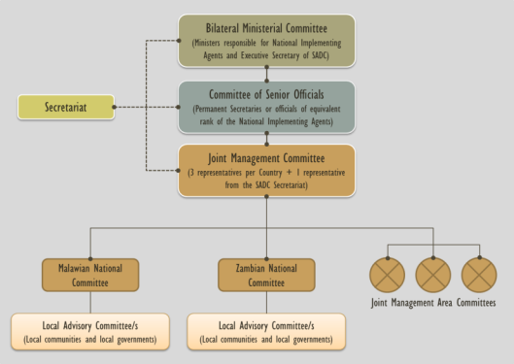
Figure 7. Treaty-based Institutional Arrangements for Implementation of the IDP
The performance of these structures, within the context of TFCA development, will be measured against the regularity of meetings, the documentation emanating from these meetings, and the reporting between the various structures.
The establishment of a Secretariat will require key steps such as a formal discussion by the various TFCA structures, with the decision recorded. Following this the drafting of the Articles of Association (AoA) or Constitution needs to be undertaken, as well as the signing of these statutory requirements for the establishment of the Secretariat. The overarching alignment of the Secretariat’s reporting lines, staff and funding must be undertaken, and regular meetings arranged and documented regarding the TFCA development path and the role and function of the Secretariat established on behalf of the two TFCA partner states. District level administration in the institutional arrangements is crucial, as well as the importance of clarifying the role of Implementing Agents in administering funds. Without these the implementation of projects could face challenges.

Table 8. KPA (2)-Institional Arrangements KPIs
KPA (2)-INSTITUTIONAL ARRANGEMENTS
Ensuring that the institutional arrangements and structures are functional and representative of all stakeholders and that the legal status of the Malawi-Zambia TFCA is clarified and properly delineated

KEY PERFORMANCE INDICATOR |  | ACTION | TIME FRAME | BUDGET (US$)
2.1 Memorandum of Understanding | Done |  | N/A
2.2 Treaty | Done (assuming that the Treaty will be signed before the IDP is approved) |  | N/A
2.3 Joint Formalised Structures | Establish efficient and effective Joint Formalised Structures-
2.3 Joint Formalised Structures | Structures appointed as per the Treaty and IDP |  | 2014 | 15,000
2.3 Joint Formalised Structures | Capacity building of officials participating in structures |  | 2015 and on-going (bi-annually) | 150,000
2.3 Joint Formalised Structures | Scheduling meetings and ensuring that these take place:  (BMC: 10,000/year  COSO: 10,000/year  JMC: 40,000/year  Country Committees: 40,000/year  JMA Committees: 70,000/year) |  | As per Treaty over 10 years | 1,700,000
2.3 Joint Formalised Structures | Preparing reports as per Terms of Reference (ToR) for each TFCA structure. |  | As specified | 100,000
2.4 Secretariat | Establish a Secretariat for the Malawi-Zambia TFCA-
2.4 Secretariat | Formally discussing the matter between the Partner Countries and recording the decision |  | 2014 | -
2.4 Secretariat | Clarify the role of and support by Implementing Agent/s |  | 2014 | 30,000
2.4 Secretariat | Drafting the relevant documentation pertaining to the establishment of the Secretariat |  | 2014-2015 | 30,000
2.4 Secretariat | Appointing the relevant staff as per record of decision. |  | 2014-2015 | 1,500,000  (Salaries and operational costs)
TOTAL |  |  |  | 3,495,000

Note:
- Include specific actions regarding internal and external communication under KPA 2 and 7
- Add an action on preparation and implementation of a retention and capacity building strategy, noting the importance of local personnel and expertise

KPA (3)-Sustainable Financing
Ensuring that the Malawi-Zambia TFCA is properly financed it is essential to attain the objectives of the TFCA as captured within the Treaty. To attain this the TFCA partner countries must prepare a Financial Sustainability Strategy (FSS), which would consist of reviewing best practices regarding financing mechanisms for the Malawi-Zambia TFCA, deciding on options and preparing a draft FSS, for approval by the relevant TFCA structures.
Once the FSS has been developed and approved an implementation plan needs to be done, which could be tasked to a Specialist Working Group in terms of the Treaty. This Working Group could prepare the Fundraising Strategy based on the FSS and endeavour to secure the funding required.
Establishing Financial Mechanisms to enable the effective financial management of funds secured is essential, as would be training programmes for staff and officials. These mechanisms must be based on the FSS and Implementation Plan.
Crucial to measuring the success of the TFCA, would be the Monitoring and Evaluation (M&E) systems that are established and implemented for the FSS, the Implementation Plan, aimed at measuring the efficacy of the Financial Mechanisms that are put into place. Regular reports need to be provided to the various TFCA structures, showing to what degree the financial sustainability of the TFCA is being attained.
The Malawi-Zambia TFCA has been able to mobilise substantial resources from several sources (refer subsection 3.2) including among other GEF and the Norwegian Government/Embassy. Ensuring that this continues requires that the steps highlighted in this KPA and associated KPIs be initiated, implemented, monitored, evaluated and reported on.
Note: Add a table on funding and how this will be spread across the various KPAs – consider where this should fit – here or under 4.10

Table 9. KPA (3)-Sustainable Financing KPIs
KPA (3)-SUSTAINABLE FINANCING
Ensuring that sufficient funding is available, since without these funds it will not be possible to implement many of the actions and attain the envisaged objectives

KEY PERFORMANCE INDICATOR | ACTION | TIME FRAME | BUDGET (US$)
3.1 Financial Sustainability Strategy | Prepare a FSS by establishing a Specialist Working Group and assigning clear responsibility for ensuring the preparation of the FSS, by:
3.1 Financial Sustainability Strategy | Undertaking a review of best practices regarding financing mechanisms for TFCAs | 2014 | 50,000
3.1 Financial Sustainability Strategy | Analysing options and a Record of Decision (RoD) prepared | 2014 | 50,000
3.1 Financial Sustainability Strategy | Preparing a draft FSS | 2014 | 50,000
3.1 Financial Sustainability Strategy | Submitting the FSS for approval. | 2015 | 50,000
3.2 FSS Implementation Plan | Develop and implement the FSS by:
3.2 FSS Implementation Plan | Preparing an implementation plan | 2015 | 100,000
3.2 FSS Implementation Plan | Having the Implementation formally approved by the TFCA structures | 2015 | 100,000
3.2 FSS Implementation Plan | Prepare a fundraising strategy and secure funding. | 2015 and as per strategy | 100,000
3.3 Financial Mechanisms | Ensure mechanisms are in place to enable effective financial management of the TFCA by-
3.3 Financial Mechanisms | Establishing financial mechanisms in terms of the FSS | 2015-2016 | 50,000
3.3 Financial Mechanisms | Developing and implementing a programme for training of staff / officials. | 2015-2016 | 50,000
3.4 Monitoring and Evaluation | Develop and implement strategies to monitor the sustainability of financing and the implementation of the FSS and Implementation Plan by-
3.4 Monitoring and Evaluation | Developing a M&E system | 2015-2016 | 80,000
3.4 Monitoring and Evaluation | Implementing the M&E system, preparing reports and submitting these to the relevant structures of the TFCA. | 2016 onwards | 80,000
TOTAL |  |  | 280,000

KPA (4)-Policy Harmonisation
The development and implementation of TFCAs are guided and formalised by International Agreements, MoU, and International Treaties, which in turn are influenced by international protocols and other relevant international conventions and legislation.
Management of TFCAs is however, largely directed by the national legislation of governments as applicable to the various component parts and chiefly those governing national parks, wildlife reserves, GMAs and forest reserves, in the instance of this TFCA (refer subsection 2.2.4, Table 4).
It is crucial to recognise that not all the policies will be aligned or harmonised simultaneously. Once the TFCA structures have identified the specific management interventions that would require policy harmonisation, as well as the level at which this must be undertaken, the relevant procedures can be initiated.
Standard Operating Procedures (SOP) based on current legislation and regulations would often provide the various TFCA structures, Specialist Working Groups, and JMA or Park Management Committees sufficient opportunity to undertake key interventions within the TFCA. To develop these SOPs the various policies as well as empowering legislation would require review, followed by the drafting of new or amended SOPs addressing the key interventions. Training programmes for staff and personnel would then require implementation to ensure that the staff know and understand the SOPs, policies and procedures.
At pre-determined intervals each SOP can be reviewed and amended, based on the efficacy and relevance of the specific procedure within the context of attaining the objectives of the TFCA.
Initial focus areas for policy harmonisation could include aspects such as:
- Tourism movement – people, goods and services
- Gate Hours and fees
- The use of undesignated ports of entry
- Law enforcement – patrols, firearms, equipment
- Intelligence and sharing of information
- Research protocols
- Community engagement, support and monitoring.
These focus areas should be clustered to ensure that the Specialist Working Group responsible for this can engage the relevant stakeholders appropriately regarding the levels of harmonisation that must take place, and prepare the details for each accordingly.
Rather than attempting full-scale law reform, the ideal would be to focus on the development of SOPs for the specific component being addressed, and having the relevant officials provide the details for this. If certain legislative restrictions prevent this from happening, it would require discussion and amendment accordingly.
Table 10. KPA (4)-Policy Harmonisation
KPA (4)-POLICY HARMONISATION
Establishing a conducive environment by ensuring synergy between operational policies utilised by the partner countries, cognisant of the sovereignty

KEY PERFORMANCE INDICATOR | ACTION | TIME FRAME | BUDGET (US$)
4.1 Policy and Legal Database | Appointing a Specialist Working Group to ensure that a detailed Policy and Legal Database for the TFCA is in place that includes all relevant policies and legal instruments collected at international, regional and national levels (refer subsection 2.2.4). | 2014 | 10,000
4.2 Assessment and Review | Review the relevant legal instruments, policies and standard operating procedures regarding envisaged joint operational areas by-
4.2 Assessment and Review | Defining the issues requiring harmonised policies and recording the decision | 2014 | 50,000
4.2 Assessment and Review | Preparing terms of reference for the processes (including stakeholder engagement strategies) | 2014 | 50,000
4.2 Assessment and Review | Undertaking the reviews as per the Terms of References and preparing a draft review report for each of the joint operational areas identified | 2014-2015 | 50,000
4.2 Assessment and Review | Approving the Legal Review Reports. | 2015 | 50,000
4.3 Policy Development/Reform | Where necessary undertake policy harmonisation to assist in joint operations by-
4.3 Policy Development/Reform | Drafting and approving revised policies or legal instruments, inclusive of Standard Operating Procedures | 2015-2016 | 100,000
4.3 Policy Development/Reform | Approving revised policies or legal instruments. | 2016 | 100,000
4.4 Harmonised Policies | Administration of harmonised policies by -
4.4 Harmonised Policies | Communicating harmonised policies or legal instruments between Partner Countries and relevant stakeholders | 2016 onwards | 30,000
4.4 Harmonised Policies | Updating the TFCA policy and legal database | 2016-2017 | -
4.4 Harmonised Policies | Developing and implementing a training programme for relevant officials | 2016 onwards | 90,000
TOTAL |  |  | 280,000

KPA (5)-Sustaining and Restoring landscape dynamics
As part of this IDP a desktop Geographic Information Systems (or GIS) survey was done to ascertain the landscape dynamics regarding the key features of the Malawi-Zambia TFCA. This included an analysis of the main encumbrances that influence the effective functioning of the ecosystem (refer subsection 2.2.1).
The following highlight a few of the key factors regarding the region from a catchment and habitat perspective. The key environmental drivers seem to be:
- Environmental factors such as elevation (refer Map 7 and Map 8)
- Availability of water (refer Map 10)
- Fire (refer Map 12)
- Presence of people (refer Map 15).
The priorities for biodiversity conservation in the TFCA are:
- Growing wildlife numbers
- Forest rehabilitation
- Catchment management
- Fire management
- Alien invasive species management
- Sustainable utilisation of natural resources.
Detail surveys, inclusive of the appointment of a Specialist Advisor to guide and facilitate this process will aid the process tremendously. Without a clear understanding of the value of sustaining and restoring landscape dynamics it will be difficult to plan and implement the various conservation initiatives.
It is essential that a Specialist Working Group be established to prepare and implement a Joint Conservation Management Plan (JCMP), aimed at sustaining and restoring the landscape dynamics of the Malawi-Zambia TFCA. This plan should be a practical guide based on discussions between experts in conservation management on how the conservation objectives contained in the treaty will be attained. This should include aspects such as the role that the Malawi Zambia TFCA can play in providing an effective ecological gradient for mitigating the impact of climate change.
Once the Specialist Working Group has prepared a draft JCMP it can be submitted to the various TFCA structures for approval and implementation, through the development of joint programmes and projects coordinated and aligned with the management plans for the individual components and protected areas within the TFCA.
The Specialist Working Group must include within the JCMP strategies to measure, monitor and evaluate the ecosystem health, habitat integrity and effective functioning of the TFCA, and prepare reports for the various TFCA structures.

Table 11. KPA (5)-Landscape Dynamics KPIs
KPA (5)-LANDSCAPE DYNAMICS
Sustaining the ecosystem integrity of the Malawi-Zambia TFCA where intact and restoring it where fragmented

KEY PERFORMANCE INDICATOR | ACTION | TIME FRAME | BUDGET (US$)
5.1 Survey | Establish a Specialist Working Group to conduct a survey of the Malawi Zambia TFCA and present this to the TFCA structure, aligned with review of PA Management Plans (appoint a specialist to assist working group). | 2014-2015 | 130,000
5.2 Joint Plan | Draft a JCMP for submission to the TFCA structures for approval (in conjunction with Protected Area plans). | 2014-2015 | 130,000
5.3 Operationalisation | Implement the JCMP by-
5.3 Operationalisation | Developing joint programmes and projects | 2015 | 400,000
5.3 Operationalisation | Implementing joint programmes and plans. | 2016 onwards | 400,000
5.4 Monitoring and Evaluation | Develop and implement strategies to monitor the health functioning of the ecosystems of the TFCA by-
5.4 Monitoring and Evaluation | Developing an ecosystem health and function M&E system (the system must be developed in conjunction with JCMP) | 2015 | -
5.4 Monitoring and Evaluation | Implementing the M&E system, preparing and submitting ecosystem health and function reports to the relevant structures of the TFCA. | 2016 onwards | 90,000
TOTAL |  |  | 620,000

KPA (6)-Tourism Development
Note: check scope – ‘human development’ to be addressed under KPA 7
For the Malawi-Zambia TFCA to truly attain its objectives it is crucial that an environment conducive for integrated regional development be established. To enable this, the TFCA structures must build forth on the platform established by this IDP, incorporating a regional development strategy collectively shared by the countries.
Improving both road and aerial access to the Malawi-Zambia TFCA would be hugely beneficial to the region and its people, and this would entail upgrades of key routes such as flights directly from Lusaka to Nyika, as well as improved road access both to and within the parks.
Aerial access between the core components would include airstrips at North Luangwa, Vwaza Marsh and Nyika, enabling both regional and international flights.
Ensuring appropriate Ports of Entry within the TFCA to enable legal movement of tourists between the countries where necessary is important - proposed Ports of Entry include Muyombe/Katumbi and Kaperekezi Gate.
The TFCA Tourism Product Development Strategy conceptually developed and included in the IDP requires funding to be secured and implementation to be undertaken, so that potential inherent within the TFCA can be unlocked. This will include seamless tourism access to key areas, such as the Nyika Plateau and the Greater Vwaza Marsh Wildlife Reserve, by developing Standard Operating Procedures for the movement of people, goods and services within these core areas.
The Malawi-Zambia TFCA has a strong story line regarding wildlife, based on the number of endemic species such as Blue swallow and orchids, as well as presence of iconic species, such as lion, elephant, buffalo, roan, sable and rhino. This nature based attraction is supported by a strong underlying cultural element in the region.
Based on these features, the Malawi-Zambia TFCA could develop tourism routes and products utilising themes such as:
- Cultural Heritage
- Luangwa – ‘From Source to Zi’ – the Zambezi
- Special Interest - North Luangwa Black Rhino Rescue
- Special Interest – Nyika Orchids; Blue Swallow; other endemics
- Wilderness and Wildlife
- Adventure activities including hiking, mountain biking, and horse trails.
To improve access within the TFCA, efforts will need to be made to improve access to information as well. For this the TFCA structures must establish a Malawi-Zambia TFCA website, which can serve as a portal for information pertaining to the region, its attractions, the people and the tourism products offered, and should include a bookings service for visitors. This should also form part of the marketing strategy for the TFCA, which should be aligned with the tourism marketing campaigns of both countries.

Table 12. KPA (6)-Tourism Development KPIs
KPA (6)-TOURISM DEVELOPMENT
Since the objectives of the Malawi-Zambia TFCA extend beyond conservation and include socio-economic development and public enjoyment it is imperative that regional development strategies be jointly implemented

KEY PERFORMANCE INDICATOR | ACTION | TIME FRAME | BUDGET (US$)
7.1 Regional Development Strategy | Appoint a Specialist Working Group to conduct a survey and develop a Regional Development Strategy as conceptualised in the IDP along with a fundraising strategy for implementation. | 2014-2015 | 150,000
7.2 TFCA Tourism Product Strategy | Appoint a Specialist Working Group to develop a TFCA tourism product development strategy as conceptualised in the IDP along with a fundraising strategy for implementation. | 2014-2015 | 150,000
7.3TFCA Tourism Product Development | Within and between the countries, implement the TFCA Tourism Development strategy regarding integrated development activities, specifically relating to tourism, inclusive of-
7.3TFCA Tourism Product Development | In Situ development – infrastructure and activities | 2015-2017 | 8,000,000
7.3TFCA Tourism Product Development | Staff training (products) | 2016 | 200,000
7.3TFCA Tourism Product Development | Developing a website and booking system | 2015 | 50,000
7.3TFCA Tourism Product Development | Developing and implementing a tourism marketing strategy | 2015 onwards | 100,000
7.3TFCA Tourism Product Development | Monitoring and reporting on guest satisfaction. | 2015 onwards | 100,000
7.4 Improved Tourism Access | Ensure that the TFCA is easily accessible and attractive to both investors and tourists, which should include-
7.4 Improved Tourism Access | Discussions regarding the movement of people, goods and services | 2014 | -
7.4 Improved Tourism Access | Preparing and seeking approval for SOPs | 2015 | 50,000
7.4 Improved Tourism Access | Preparing and implementing M&E systems and reporting to the relevant structures of the TFCA. | 2015 onwards | 30,000
TOTAL |  |  | 8,680,000

Note: Include specific actions regarding internal and external communication under KPA 2 and 7

KPA (7)-Community Development
To ensure that conservation is recognised as a viable and sustainable land use option it is critical that the understanding regarding the range of benefits emanating from conservation to the region and its people is broadened. These benefits should be quantified and the results reported on to both the TFCA structures and the communities affected by conservation initiatives. These benefits should include aspects such as, inter alia:
- Biodiversity
- Ecosystem Services
- Access to and use of natural and cultural resources by local communities
- Research opportunities
- Human resource development and training
- Direct Foreign Investment
- Community equity in ecotourism and related investments
- Broadening of the Tax Base
- Awareness and sensitisation
- Employment, skills development and training opportunities.
Critical actions that the TFCA structures need to undertake include a Benefit Flow Benchmarking exercise, aimed at identifying measurable criteria, conducting a survey to ascertain current benefit flow levels and preparing a report for future reference, as well as the preparation of Beneficiation Action Plans (BAPs) for the TFCA. These BAPs are based on specific strategies for addressing benefits to stakeholders, through consultation and discussion with the stakeholders, that are converted into BAPs that are approved and supported by the TFCA structures through various TFCA programmes and projects, the securing of funding and implementation initiatives.
These initiatives must be monitored and evaluated against the baseline criteria identified during the first steps of the KPA, and reports prepared for the structures showing the benefits of the TFCA for the region.

Table 13. KPA (7)-Community Development KPIs
KPA (7)- Community Development
Broadening the understanding that conservation is a viable and sustainable land use option that can provide a broad range of benefits to the region and its people, as well as quantifying the benefits and reporting on the impact of the conservation initiatives on the affected communities

KEY PERFORMANCE INDICATOR | ACTION | TIME FRAME | BUDGET (US$)
8.1 Baseline Assessment | Appoint a Specialist Working Group to conduct a baseline Benefit Flow Benchmarking exercise for the TFCA which should include determining measurable criteria and undertaking the survey and preparation of report | 2014-2015 | 100,000
8.2 Beneficiation Action Plans | The SWG should prepare and request approval of BAPs for the Malawi Zambia TFCA, which must include specific strategies for addressing benefits to stakeholders that have been agreed upon. | 2015-2016 | 75,000
8.3 Implementation of BAPs | Within and between the TFCA partner countries implement the various BAPs based on the Programmes and Projects that have been developed and the funding that has been secured. | 2016 onwards | 3,600,000
8.4 M&E and Reporting | The SWG should develop and implement measures and monitoring techniques and prepare reports regarding benefits from the TFCA, and present these to the Malawi Zambia TFCA structures. | 2015 onwards | 100,000
TOTAL |  |  | 3,875,000

KPA (8)-Integrated Management
Within the Bambanda-Zaro Sanctuary, management has been integrated for the past few years, with joint activities being undertaken between the two TFCA partner countries. This approach to conservation management has laid the foundation for integrated management not just within the Malawi Zambia TFCA, but across the entire SADC region. Formalisation of the approach is needed to ensure its efficacy and sustainability.
Due to the absence of a formal mandate for these joint activities it would be prudent to wait till the Treaty has been signed before implementing these integrated management interventions.
Realigning the management of the various protected areas and conservation programmes within the Malawi-Zambia TFCA will contribute significantly to improving the current situation. Integrating the conservation management within the Malawi-Zambia TFCA will be an effective way to attain the objectives of the TFCA. Rather than having separate management structures addressing key interventions identified as crucial to the success of the TFCA, combining efforts within identified and functional ecological management units can contribute to the attainment of the objectives of the TFCA in an effective and efficient manner. The joint interventions that have already been undertaken within the Malawi-Zambia TFCA have become recognised as best practice within the region. Based on these successes the joint management initiatives can be expanded and further developed.
It is recommended that the TFCA structures of the Malawi-Zambia TFCA formally decide on Integrated Management opportunities within the TFCA, based on the concepts contained in the IDP.
Functional areas where jointly managed initiatives can be undertaken include:
- Policy harmonisation
- Fundraising
- Community outreach and engagement
- Benefit flow management and reporting
- Tourism development
- Marketing and awareness regarding the Malawi-Zambia TFCA.
Note: add specific reference to law enforcement
Specialist Working Groups can be established and tasked with the responsibility to undertake these activities in an integrated and aligned manner, based on Joint Operational Strategies guided by the JCMP. These strategies should be approved by the TFCA structures.
The key geographical areas where joint management activities can be integrated include, inter alia:
- Nyika Plateau
- Greater Vwaza Marsh area (or Vwaza Block)
- Escarpment area south of Vwaza Marsh.
As introduced to in subsection 4.3, it is recommended that Joint Management Areas be identified and that Park Management Committees be established for these areas. The PMCs plan, implement, monitor and evaluate, as well as report on joint activities to the TFCA structures, which should include joint law enforcement, patrols, research, HWC management and mitigation, community engagement and awareness and sensitisation programme implementation.
Whether to support the joint or collaborating initiatives of the TFCA regarding integrated management, it is recommended that Joint Operational Centres (JOCs) be established for each of these areas. The key geographical JOCs will be at Nyika and the Greater Vwaza Marsh area, which can also oversee the escarpment area, while JOCs for the other activities can be discussed and established as and when required to address the specific functional area being addressed. The JOCs can be temporal in nature, as opposed to the permanent nature of the two JOCs for the jointly managed protected area components.
To further attain the conservation objectives of the Malawi-Zambia TFCA, certain activities will be undertaken separately, yet on the same standard, within a single country. It is crucial that these activities be co-ordinated and aligned, so that the reports regarding the conservation objectives of the TFCA can collectively be prepared for submission to the TFCA structures. These collaborative activities, aligned with certain standards, and guided by Standard Operational Procedures for the activities, will enable this to happen.
Typically, activities within the following geographical areas would be implemented as collaborative conservation initiatives, at the same standard and level as the jointly managed areas, rather than as jointly undertaken activities, due to the physical location within Zambia:
- North Luangwa National Park
- Musalangu GMA.
Once joint or collaborative activities are undertaken, reports must be prepared for the Malawi Zambia TFCA structures showing the impact of such joint activities. The basis of these reports should be on the regular monitoring and evaluation that is done by the Park Management Committees, by the individual park management structures or by the Specialist Working Groups established for this.

Table 14. KPA (8)-Integrated Management KPIs
KPA (8)-INTEGRATED MANAGEMENT
Sustain and restore the ecosystem integrity of the Malawi-Zambia TFCA, it is critical that integrated management be undertaken between the partner countries conservation agencies

KEY PERFORMANCE INDICATOR | ACTION | TIME FRAME | BUDGET (US$)
6.1 Joint Management Decision | Take decisions as to jointly managing components of the TFCA through-
6.1 Joint Management Decision | Formal discussions between the Partner Countries and preparing Records of Decision | 2014-2015 | -
6.1 Joint Management Decision | Appointing a Specialist Working Group to prepare Joint Operational Strategies. | 2015 | 20,000
6.1 Joint Operational Strategy (JOS) | Develop JOSs for JMAs by-
6.1 Joint Operational Strategy (JOS) | Reaching consensus on which joint activities can be undertaken | 2014-2015 | 150,000
6.1 Joint Operational Strategy (JOS) | Drafting the JOSs and identifying appropriate institutional arrangements for implementation | 2015 | 150,000
6.1 Joint Operational Strategy (JOS) | Submitting the JOS’ for approval by the relevant structure/s of the TFCA. | 2015 | 150,000
6.3 Joint Operations Centre / Structure | Establish Joint Operations Structures by-
6.3 Joint Operations Centre / Structure | Appointing the envisaged Park Management Committees as per approved JOS’ | 2015 | -
6.3 Joint Operations Centre / Structure | Identifying and seconding staff to the PMCs | 2015 -2016 | -
6.3 Joint Operations Centre / Structure | Developing systems and SOPs and ensuring that these are being implemented | 2016 | 75,000
6.4 Joint Operations | Joint operations need to be undertaken within the PMCs by undertaking-
6.4 Joint Operations | Regular joint activities in terms of SOPs | 2016 onwards | 1,200,000
6.4 Joint Operations | Develop a M&E system | 2016 | 1,200,000
6.4 Joint Operations | Implement M&E system with regular reporting to the TFCA structures. | 2016 onwards | 1,200,000
TOTAL |  |  | 1,445,000

Programme and Budget Summary
Note: revisit considering what is available in terms of the various Project Plans
It is estimated that a total of approximately US$40,000,000 would be required over the next ten years within the Malawi Zambia TFCA to ensure that both the TFCA objectives as well as the individual protected area objectives can be met. Given that commitments from international co-operation partners have been attained, the shortfall would be approximately US$6,500,000.
The tables below provide a summary of the budget requirements per Key Performance Area, and the timelines at which each key Performance indicator should be met to ensure synergies and momentum being maintained with the development of the TFCA.
Table 15. Summary Budget Requirements
KEY PERFORMANCE AREA | BUDGET (US$)
KPA (1)-Joint Planning | 21,100,000
KPA (2)-Institutional Arrangements | 3,495,000
KPA (3)-Sustainable Financing | 280,000
KPA (4)-Policy Harmonisation | 280,000
KPA (5)-Landscape Dynamics | 620,000
KPA (6)-Integrated Management | 1,445,000
KPA (7)-Integrated Development | 8,680,000
KPA (8)-Benefit Flow Management | 3,875,000
TOTAL | 39,775,000

Table 16. IDP Implementation Programme
KEY PERFORMANCE AREA |  | 2014 | 2015 | 2016 | 2017 | 2018 | 2019 | 2020 | 2021 | 2022 | 2023
KPA (1)-Joint Planning
Aligned Protected Area Plans | Review of plans | X | X
Aligned Protected Area Plans | Draft revised plans |  | X
Aligned Protected Area Plans | Approved plans |  |  | X
Aligned Protected Area Plans | Implementation of aligned plans |  |  | X | X | X | X | X | X | X | X
Detailed IDP Roll-out | Strategic Business Plan/s | X |  |  |  |  |  |  |  | X
Detailed IDP Roll-out | Annual Business Plan/s | X | X | X | X | X | X | X | X | X | X
Detailed IDP Roll-out | Annual Review/s | X | X | X | X | X | X | X | X | X | X
Detailed IDP Roll-out | Annual Report/s | X | X | X | X | X | X | X | X | X | X
KPA (2)-Institutional Arrangements
Joint Formalised Structures | Structures appointed | X
Joint Formalised Structures | Capacity building |  | X |  | X |  | X |  | X |  | X
Joint Formalised Structures | Meetings (minutes) | X | X | X | X | X | X | X | X | X | X
Joint Formalised Structures | Reports | X | X | X | X | X | X | X | X | X | X
Secretariat | Formal discussions and RoD | X
Secretariat | Implementing Agent/s | X
Secretariat | Establishment | X | X
Secretariat | Appointed /seconded staff | X | X
KPA (3)-Sustainable Financing
Financial Sustainability Strategy | Best Practices Review | X
Financial Sustainability Strategy | Options Analysis and RoD | X
Financial Sustainability Strategy | Draft FSS | X
Financial Sustainability Strategy | Approved FSS |  | X
Financial Sustainability Plan | Implementation Plan |  | X
Financial Sustainability Plan | Fundraising Strategies |  | X
Financial Sustainability Plan | Secured Funding |  | X | X | X | X | X | X | X | X | X
Financial Mechanisms | Financial Mechanisms |  | X | X
Financial Mechanisms | Training Programme |  | X | X |  | X |  | X |  | X
M&E and Reporting | M&E System |  | X | X
M&E and Reporting | Reports |  |  | X | X | X | X | X | X | X | X
KPA (4)-Policy Harmonsiation
Policy and Legal Database | Specialist Working Group | X
Policy and Legal Database | Policies & Instruments collected | X
Policy and Legal Database | Database | X
Assessment and Review | Joint issues defined | X
Assessment and Review | ToR / Scope of Work | X
Assessment and Review | Draft Review Report/s | X | X
Assessment and Review | Review Report/s approved |  | X
Policy Development / Law Reform | Draft Revised Instruments |  | X | X
Policy Development / Law Reform | Approved Instruments |  |  | X
Harmonised Policies | Communication |  |  | X | X | X | X | X | X | X | X
Harmonised Policies | Policy & legal database updated |  |  | X
Harmonised Policies | Training / capacity building programme |  |  | X |  | X |  | X |  | X
KPA (5)-Landscape Dynamics
Survey | Specialist Working Group and Specialist Advisor appointed | X | X
Survey | Survey report |  | X
Joint Plan | Draft JCMP |  | X
Joint Plan | Approved JCMP |  | X
Operationalisation | Programmes and Projects |  | X
Operationalisation | Implementation |  |  | X | X | X | X | X | X | X | X
M&E and Reporting | M&E System |  | X
M&E and Reporting | Reporting |  |  | X | X | X | X | X | X | X | X
KPA (6)-Integrated Management
Joint Management Decision | Formal discussions and RoD | X | X
Joint Management Decision | Working group appointed |  | X
Joint Operational Strategy | Consensus on joint activities | X | X
Joint Operational Strategy | Draft JOS |  | X
Joint Operational Strategy | Approved JOS |  | X
Joint Operational Structure | Joint Operations Structure appointed |  | X
Joint Operational Structure | Staff identified / seconded |  | X
Joint Operational Structure | Systems and SOPs |  | X
Joint Operations | Regular joint activities |  | X | X | X | X | X | X | X | X | X
Joint Operations | M&E System |  | X
Joint Operations | Implementation and regular reports |  | X | X | X | X | X | X | X | X | X
KPA (7)-Integrated Development
Regional Development Strategy | Draft Strategy | X | X
Regional Development Strategy | Approved Strategy |  | X
TFCA Development Strategy | Draft Strategy |  | X
TFCA Development Strategy | Approved Strategy |  | X
TFCA Tourism Products | In Situ development |  | X | X | X | X
TFCA Tourism Products | Staff training |  |  | X
TFCA Tourism Products | Booking System |  | X
TFCA Tourism Products | Marketing Strategy |  | X | X | X | X | X | X | X | X | X
TFCA Tourism Products | M&E and Reporting |  | X | X | X | X | X | X | X | X | X
Improved Tourism Access | Discussions & RoD | X
Improved Tourism Access | Draft SOPs and approvals |  | X
Improved Tourism Access | M&E and Reporting |  | X | X | X | X | X | X | X | X | X
KPA (8)-Benefit Flow Management
Baseline Assessment | Survey and Draft Report | X | X
Baseline Assessment | Approved Survey Report |  | X
Beneficiation Action Plan | Draft BAP |  | X
Beneficiation Action Plan | Approved BAP |  |  | X
Implementation | Approved Plans and Programmes (P&P) |  |  | X
Implementation | Implementation of P&Ps |  |  | X | X | X | X | X | X | X | X
M&E and Reporting | M&E System & Techniques |  | X
M&E and Reporting | Reports |  |  | X | X | X | X | X | X | X | X

APPENDICES

Appendix 1: Map References
Table 17. Map References
<To be completed once all map changes have been made>
no | description | Layer/s | Layer Source
1 | Locality
2 | IDP Focus Area
3 | Nyika national parks
4 | Vwasa March Wildlife Reserve
5 | Musalanga GMA
6 | North Luangwa NP
7 | Elevation
8 | Habitat Value
9 | Catchments
10 | Vegetation
11 | Fire
12 | Current Environmental Character
13 | Human Footprint
14 | Nyika Plateau Concession Areas and Tourism Development Sites
15 | Vwasa March Concession Areas and Tourism Development Sites
16 | Musalanga GMA Concession Areas and Tourism Development Sites
17 | North Luangwa Concession Areas and Tourism Development Sites
18 | Access Points and Main Routes

Appendix 2: Stakeholders Process for the Preparation of the IDP
DATES | PURPOSE | LOCATION | COMMENTS
19 February 2013 | Joint Project Team Meeting - Project Planning | Chipata, Zambia | Refer Process Plan
12 March 2013 | Country-based Stakeholder Meeting - IDP Introduction | Rumphi, Malawi | Refer Agenda and Meeting Report
27 March 2013 | Country-based Stakeholder Meeting - IDP Introduction | Chama, Zambia | Refer Agenda and Meeting Report
25 June 2013 | Country-based Stakeholder Meeting | Chama, Zambia | Refer Agenda, Meeting Notes
26 June 2013 | Country-based Stakeholder Meeting | Rumphi, Malawi | Refer Agenda, Meeting Notes and Report
28 June 2013 | 1st Bi-Lateral Technical Meeting | Mzuzu, Malawi | Refer List of Additional Background Documents
09 October 2013 | 2ndBi-Lateral Technical Meeting | Chipata, Zambia
18 November 2013 | Joint Steering Committee Meeting | Lusaka, Zambia | Presentation of Draft IDP
? | Print & Circulate to Stakeholders | N/A
? | Country based Consultative Meetings Comments | Malawi | Review of IDP
? | Country based Consultative Meetings Comments | Zambia | Review of IDP
15 May 2014 | 3rdBi-Lateral Technical Meeting | Chipata, Zambia | Review and finalisation of IDP – refer Agenda and Comments Register

Appendix 3: list of Stakeholders
Zambia
Office of the President
District Commissioner
Ministry of Local Government and Housing
Ministry of Health
Ministry of Education
Ministry of Agriculture and Cooperatives
Ministry of Community Development and Social Welfare
Public Works Department
Forestry Department
Zambia Wildlife Authority
Zambia Wildlife Police
Senior Kambombo Chieftaincy

Malawi
District Commissioner
Department of Forestry
Department of National Parks and Wildlife
Department of Lands
District Agriculture Development Office
Department of Water
District Education Office
District Health Office
District Development Office
Malawi Police Service
Department of Fisheries
District Labour Office
Magistrate Office
District Social Welfare Office
District Environmental Office
District Public Works Office
Catholic Development Commission of Malawi (CADECOM)
Livingstonia Synod
Total LandCare
Development for Marginalized Rural Areas (DMLAR)
Action Aid
Life Concern
Green Vision
NICE
Paramount Chikulamayembe Chieftaincy

Appendix 4: Documents Consulted in the Preparation of the IDP
The following documents supported the preparation of the IDP:
TFCA:
- Memorandum of Understanding between the Government of Malawi and the Government of Zambia on the development of the Malawi Zambia Transfrontier Conservation Areas, 2004
- Draft Treaty for the Malawi Zambia TFCA, Revised February 2013
- Nyika TFCA Joint Management Plan, June 2007
- Draft Tourism Development Plan for the Nyika TFCA, November 2006
Malawi specific:
- Rumphi District Council documentation:
- District rural water, sanitation and hygiene programme - district strategy and investment plan, May 2010 (2010-2015)
- Current Water Situation
- District Development Plan (2010-2013)
- Socio-economic profile, February 2009
- Improved Forest Management for Sustainable Livelihoods Programme – District Work Plan and Cost Estimate – Rumphi District Council. Operational Period September 2012 to November 2013
- Nyika National Park Master Plan, March 2004
- Vwaza Marsh Wildlife Reserve Master Plan, March 2004
Zambia specific:
- Draft General Management Plan for Musalangu GMA, 2014-2023
- District Development Plan for Chama District, 2011-2013
- Chama District Census Data

Appendix 5: Malawi-Zambia TFCA – Balanced Scorecard
Table 18. TFCA Development Performance Assessment Balanced Scorecard
No | KEY PERFORMANCE INDICATOR | VARIABLES | VALUE  (%) | SCORE  (2013) | SCORE  (2014) | SCORE  (2015) | SCORE  (2016) | TARGET  (2017)
KPA (1)-Joint Planning
1.1 | Motivation Document (MD) | Intergovernmental Meeting | 5 | 5
1.1 | Motivation Document (MD) | Draft MD | 5 | 5
1.1 | Motivation Document (MD) | Approved MD | 15 | 15
1.1 | Motivation Document (MD) | Sub-total | 25 | 25
1.2 | Integrated Development Plan | Defined Boundaries | 2 | 2
1.2 | Integrated Development Plan | Legal Framework | 3 | 3
1.2 | Integrated Development Plan | Stakeholder Engagement | 2.5 | 2.5
1.2 | Integrated Development Plan | Draft IDP | 7.5 | 7.5
1.2 | Integrated Development Plan | Approved IDP | 10 | 10
1.2 | Integrated Development Plan | Sub-total | 25 | 25
1.3 | Aligned Protected Area Plans | Review of plans | 5 | 0
1.3 | Aligned Protected Area Plans | Draft revised plans | 5 | 0
1.3 | Aligned Protected Area Plans | Approved plans | 15 | 0
1.3 | Aligned Protected Area Plans | Sub-total |  | 0
1.4 | Detailed IDP Roll-out | Strategic Business Plan/s | 7.5 | 0
1.4 | Detailed IDP Roll-out | Annual Business Plan/s | 7.5 | 0
1.4 | Detailed IDP Roll-out | Annual Review/s | 5 | 0
1.4 | Detailed IDP Roll-out | Annual Report/s | 5 | 0
1.4 | Detailed IDP Roll-out | Sub-total | 25 | 0
Sub-score |  |  | 100 | 50
KPA (2)-Institutional Arrangements
2.1 | Memorandum of Understanding | Formal discussions and RoD | 2 | 2
2.1 | Memorandum of Understanding | Draft MoU | 3 | 3
2.1 | Memorandum of Understanding | Approved MoU | 10 | 10
2.1 | Memorandum of Understanding | IC appointed | 3 | 3
2.1 | Memorandum of Understanding | Interim structures | 7 | 7
2.1 | Memorandum of Understanding | Sub-total | 25 | 25
2.2 | Treaty | Formal Discussions and RoD | 2 | 2
2.2 | Treaty | Drafting team appointed | 3 | 3
2.2 | Treaty | Draft Treaty | 5 | 5
2.2 | Treaty | Bound finalised Treaty | 5 | 5
2.2 | Treaty | Signed Treaty | 10 | 10
2.2 | Treaty | Sub-total | 25 | 25
2.3 | Joint Formalised Structures | Structures appointed | 5 | 0
2.3 | Joint Formalised Structures | Meetings (minutes) | 10 | 0
2.3 | Joint Formalised Structures | Reports | 10 | 0
2.3 | Joint Formalised Structures | Sub-total | 25 | 0
2.4 | Legal Entity | Formal discussions and RoD | 2 | 0
2.4 | Legal Entity | Draft AoA / Constitution | 3 | 0
2.4 | Legal Entity | Signed AoA / Constitution | 10 | 0
2.4 | Legal Entity | Trustee / Board appointed | 5 | 0
2.4 | Legal Entity | Regular meetings (minutes) | 5 | 0
2.4 | Legal Entity | Sub-total | 25 | 0
Sub-score |  |  | 100 | 50
KPA (3)-Sustainable Financing
3.1 | Financial Sustainability Strategy | Best Practices Review | 3 | 0
3.1 | Financial Sustainability Strategy | Options Analysis and RoD | 2 | 0
3.1 | Financial Sustainability Strategy | Draft FSS | 10 | 0
3.1 | Financial Sustainability Strategy | Approved FSS | 10 | 0
3.1 | Financial Sustainability Strategy | Sub-total | 25 | 0
3.2 | Financial Sustainability Plan | Implementation Plan | 7 | 0
3.2 | Financial Sustainability Plan | Responsibility | 3 | 0
3.2 | Financial Sustainability Plan | Fundraising Strategies | 5 | 0
3.2 | Financial Sustainability Plan | Secured Funding | 10 | 0
3.2 | Financial Sustainability Plan | Sub-total | 25 | 0
3.3 | Financial Mechanisms | Financial Mechanisms | 12.5 | 0
3.3 | Financial Mechanisms | Training Programme | 12.5 | 0
3.3 | Financial Mechanisms | Sub-total | 25 | 0
3.4 | M&E and Reporting | M&E System | 12.5 | 0
3.4 | M&E and Reporting | Reports | 12.5 | 0
3.4 | M&E and Reporting | Sub-total | 25 | 0
Sub-score |  |  | 100 | 0
KPA (4)-Policy Harmonisation
4.1 | Policy and Legal Database | Policies & Instruments collected | 12.5 | 0
4.1 | Policy and Legal Database | Database | 12.5 | 0
4.1 | Policy and Legal Database | Sub-total | 25 | 0
4.2 | Assessment and Review | Working group appointed | 2 | 0
4.2 | Assessment and Review | ToR | 3 | 0
4.2 | Assessment and Review | Draft Review Report | 10 | 0
4.2 | Assessment and Review | Review Report approved | 10 | 0
4.2 | Assessment and Review | Sub-total | 25 | 0
4.3 | Policy Development / Law Reform | RoD and Scope of Project/s | 5 | 0
4.3 | Policy Development / Law Reform | Stakeholder Engagement Strategies | 5 | 0
4.3 | Policy Development / Law Reform | Draft Revised Instruments | 7.5 | 0
4.3 | Policy Development / Law Reform | Approved Instruments | 7.5 | 0
4.3 | Policy Development / Law Reform | Sub-total | 25 | 0
4.4 | Harmonised Policies | Communication | 5 | 0
4.4 | Harmonised Policies | Policy & legal database updated | 5 | 0
4.4 | Harmonised Policies | Training building programme | 7.5 | 0
4.4 | Harmonised Policies | JOS’ & SOPs reviewed and updated | 7.5 | 0
4.4 | Harmonised Policies | Sub-total | 25 | 0
Sub-score |  |  | 100 | 0
KPA (5)-Landscape Dynamics
5.1 | Survey | Analysis | 7.5 | 7.5
5.1 | Survey | Encumbrance Survey | 2.5 | 2.5
5.1 | Survey | Environmental Drivers | 2.5 | 2.5
5.1 | Survey | Draft Survey Report | 7.5 | 7.5
5.1 | Survey | Approved Survey Report | 5 | 5
5.1 | Survey | Sub-total | 25 | 25
5.2 | Joint Plan | Objectives & Targets | 5 | 0
5.2 | Joint Plan | Draft JCMP | 10 | 0
5.2 | Joint Plan | Approved JCMP | 10 | 0
5.2 | Joint Plan | Sub-total | 25 | 0
5.3 | Operationalisation | Programmes and Projects | 10 | 0
5.3 | Operationalisation | Implementation | 10 | 0
5.3 | Operationalisation | Aligned component plans | 5 | 0
5.3 | Operationalisation | Sub-total | 25 | 0
5.4 | M&E and Reporting | M&E System | 12.5 | 0
5.4 | M&E and Reporting | Reporting | 12.5 | 0
5.4 | M&E and Reporting | Sub-total | 25 | 0
Sub-score |  |  | 100 | 25
KPA (6)-Integrated Management
6.1 | Joint Management Decision | Formal discussions | 5 | 0
6.1 | Joint Management Decision | RoD | 5 | 0
6.1 | Joint Management Decision | Working group appointed | 15 | 0
6.1 | Joint Management Decision | Sub-total | 25 | 0
6.2 | Joint Operational Strategy | Consensus on joint activities | 5 | 0
6.2 | Joint Operational Strategy | Draft JOS | 10 | 0
6.2 | Joint Operational Strategy | Approved JOS | 10 | 0
6.2 | Joint Operational Strategy | Sub-total | 25 | 0
6.3 | Joint Operational Structure | Joint Operations Structure appointed | 5 | 0
6.3 | Joint Operational Structure | Staff identified / seconded | 10 | 0
6.3 | Joint Operational Structure | Systems and SOPs | 10 | 0
6.3 | Joint Operational Structure | Sub-total | 25 | 0
6.4 | Joint Operations | Regular joint activities | 10 | 0
6.4 | Joint Operations | M&E | 7.5 | 0
6.4 | Joint Operations | Regular reports | 7.5 | 0
6.4 | Joint Operations | Sub-total | 25 | 0
Sub-score |  |  | 100 | 0
KPA (7)-Integrated Development
7.1 | Regional Development Strategy | Database | 5 | 5
7.1 | Regional Development Strategy | Draft Strategy | 10 | 10
7.1 | Regional Development Strategy | Approved Strategy | 10 | 10
7.1 | Regional Development Strategy | Sub-total | 25 | 25
7.2 | TFCA Development Strategy | Agreed concepts | 3 | 3
7.2 | TFCA Development Strategy | Draft Strategy | 5 | 0
7.2 | TFCA Development Strategy | Approved Strategy | 10 | 0
7.2 | TFCA Development Strategy | Implementation Plan & Fundraising Strategy | 7 | 0
7.2 | TFCA Development Strategy | Sub-total | 25 | 3
7.3 | TFCA Tourism Products | In Situ development | 7.5 | 0
7.3 | TFCA Tourism Products | Staff training | 5 | 0
7.3 | TFCA Tourism Products | Booking System | 2.5 | 0
7.3 | TFCA Tourism Products | Marketing Strategy | 5 | 0
7.3 | TFCA Tourism Products | M&E and Reporting | 5 | 0
7.3 | TFCA Tourism Products | Sub-total | 25 | 0
7.4 | Improved Tourism Access | Discussions & RoD | 3 | 0
7.4 | Improved Tourism Access | Draft SOP | 7 | 0
7.4 | Improved Tourism Access | Approved SOP | 10 | 0
7.4 | Improved Tourism Access | M&E and Reporting | 5 | 0
7.4 | Improved Tourism Access | Sub-total | 25 | 0
Sub-score |  |  | 100 | 28
KPA (8)-Benefit Flow Management
8.1 | Baseline Assessment | Measurable Criteria | 5 | 0
8.1 | Baseline Assessment | Survey and Draft Report | 10 | 0
8.1 | Baseline Assessment | Approved Survey Report | 10 | 0
8.1 | Baseline Assessment | Sub-total | 25 | 0
8.2 | Beneficiation Action Plan | RoD on Benefit Strategies | 7.5 | 0
8.2 | Beneficiation Action Plan | Draft BAPs | 7.5 | 0
8.2 | Beneficiation Action Plan | Approved BAPs | 10 | 0
8.2 | Beneficiation Action Plan | Sub-total | 25 | 0
8.3 | Implementation | Approved P&Ps | 7.5 | 0
8.3 | Implementation | Secured Funding | 7.5 | 0
8.3 | Implementation | Implementation of P&Ps | 10 | 0
8.3 | Implementation | Sub-total | 25 | 0
8.4 | M&E and Reporting | M&E System & Techniques | 7.5 | 0
8.4 | M&E and Reporting | Data & Information Analyses | 7.5 | 0
8.4 | M&E and Reporting | Reports | 10 | 0
8.4 | M&E and Reporting | Sub-total | 25 | 0
Sub-score |  |  | 100 | 0

SUMMARY OF SCORES
KPA (1)-Joint Planning | 50
KPA (2)-Institutional Arrangements | 25
KPA (3)-Sustainable Financing | 0
KPA (4)-Policy Harmonsiation | 0
KPA (5)-Landscape Dynamics | 25
KPA (6)-Integrated Management | 0
KPA (7)-Integrated Development | 28
KPA (8)-Benefit Flow Management | 0
TOTAL SCORE (Sub-scores / 8) | 19%

Habitat Value Formula = [Protection Status] + [Biodiversity] + [Threat Status] + [Primary Production] + [Human Footprint]* + [Food Value]* noting that criteria indicated with an asterisk have a negative value
From Roever, CL, Van Aarde, RJ & Leggett, K 2013, 'Functional connectivity within conservation networks : delineating corridors for African elephants', Biological Conservation, vol. 157, no. 1, pp. 128-135.
Refer http://www.malawilii.org/indexpage/consolidated_act/C
Refer http://www.zambialii.org/indexpage/consolidated_act

