Witsieshoek Mountain Lodge

Witsieshoek Mountain Resort is a community owned resort/hotel which is owned by Batlokoa Community in Qwaqwa, Free State Province. This resort falls within the periphery of the Maloti Drakensberg Transfrontier Conservation Area, under Transfrontier Conservation Areas Section. The Witsieshoek Resort's operations were not up to standard from 2005 to 2007 due to lack of proper management. The Maloti Drakensberg Transfrontier Project (Department of Environmental Affairs initiative) appointed the Service provider, which conducted the Business Analysis and also developed the concept Development Plan and management model of the Witsieshoek Resort. In 2008, Department of Environmental Affairs and Tourism hosted the Transfrontier Conservation Areas (TFCAs) Investor Conference in Sandton, Johannesburg. Different investment opportunities within TFCAs were showcased and promoted to the potential investors during this investor conference and the Witsieshoek Resort was one of the investment opportunities. In addition, these investment opportunities were packaged in the TFCA investment catalogue which was widely distributed around the World. It was during this investor conference where Transfrontier Park Destinations (private investment company) showed interest in investing in Witsieshoek Mountain Resort.

Witsieshoek Mountain Lodge currently has 34 full-time employees on its payroll, 32 of whom are from the local community. In addition the lodge employs on average 6 casual and intern staff on a monthly basis.

The recently renovated Witsieshoek Mountain Lodge offers 76 beds in 36 en-suite rooms as follows:
- Sentinel units (8 rooms) 16 beds
- Soutpansberg bungalow (6 rooms) 12 beds
- 4 x 6 room bungalows (24 rooms) 48 beds

The quality of the construction and furnishing of the accommodation units is such that Witsieshoek should achieve a 4-star Tourism Grading Council of South Africa grading. The only factor that may limit this achievement in the short term is the outstanding finishes required to the accommodation units and the need for upgrading the carpets in the main lodge and the furniture in the dining area and reception.

In addition the “Hiking Cabin” offers 12 beds with shared ablution facilities.

This provides Witsieshoek Mountain Lodge with the capacity to accommodate 88 guests per night.

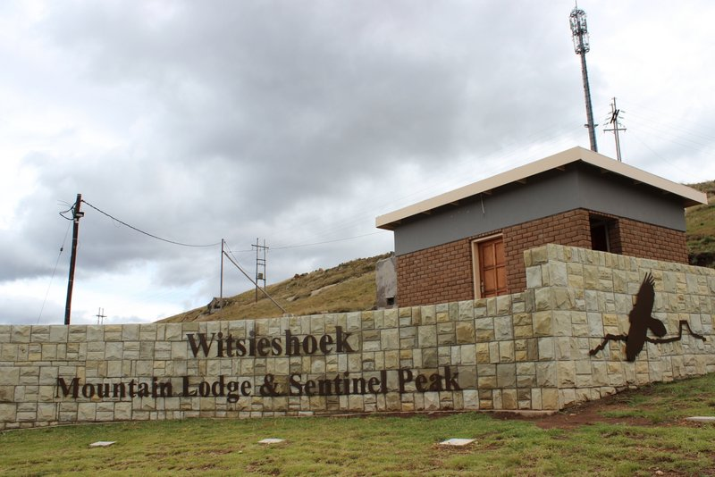

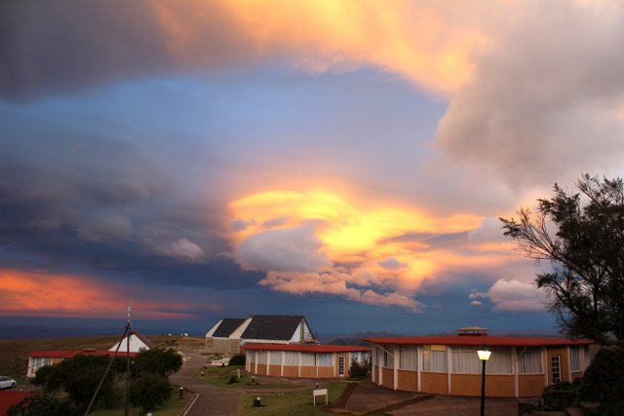

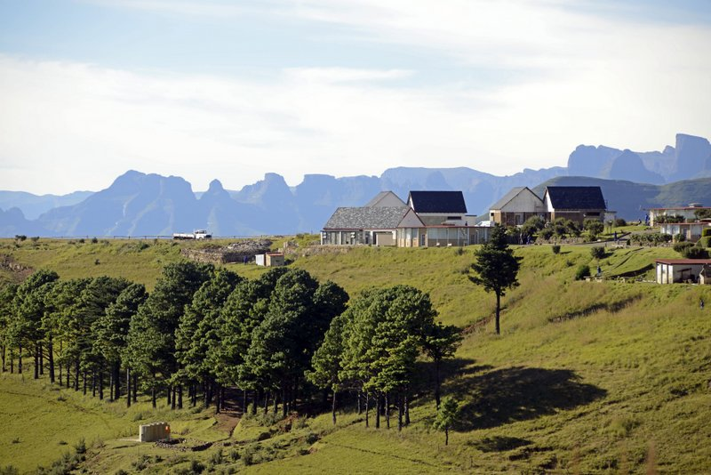

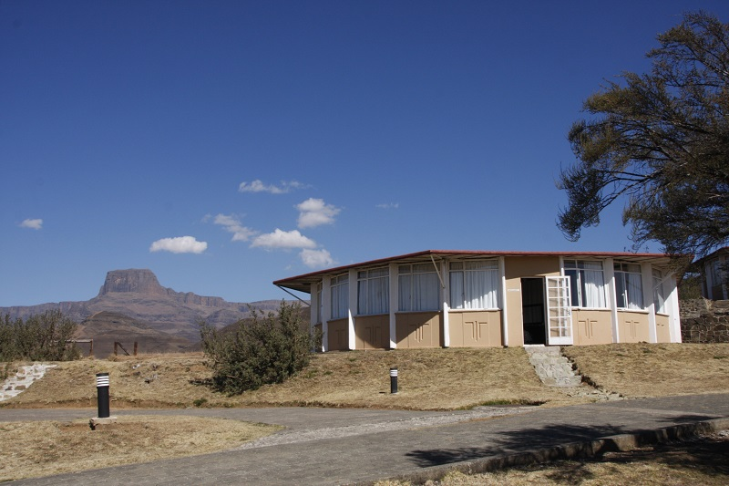
Ensuite rooms before renovation
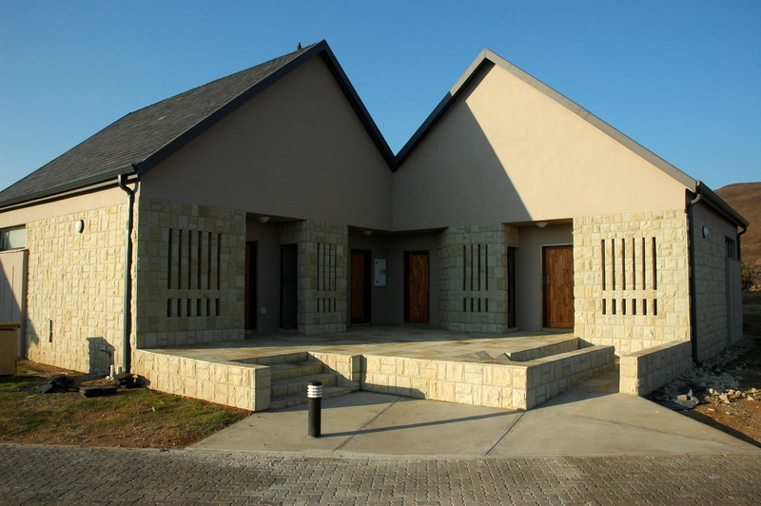
Ensuite rooms after.

